Compliance Management System

User Manual

Version 1.0  
Apr, 2016

| Notice |
| --- |
| © 2016 Tata Consultancy Services Limited  This is a controlled document. Unauthorised access, copying, replication or usage for a purpose other than for which it is intended, are prohibited.  All trademarks that appear in the document have been used for identification purposes only and belong to their respective companies. |

Document Release Note

Project: Compliance Management System

Document Details

|  |  |  |
| --- | --- | --- |
| Name | Version no. | Description |
| Compliance Management System User Manual | Version 1.0 | This document is intended to provide all the necessary information required to working with the Compliance Management System tool. |

Revision Details

|  |  |  |  |
| --- | --- | --- | --- |
| Action taken (add/del/change) | Previous page no. | New page no. | Revision description |
|  |  |  |  |

Change Register serial numbers covered:

The documents or revised pages are subject to document control.

Please keep them up-to-date using the release notices from the distributor of the document.

These are confidential documents. Unauthorised access or copying is prohibited.

|  |  |
| --- | --- |
| Approved by: | Date: |
|  |  |
| Authorised by: | Date: |

Document Revision List

Project: Compliance Management System

Document Name: CMS User Manual_V1.0

Release Notice Reference (for release)

|  |  |  |  |  |  |  |  |
| --- | --- | --- | --- | --- | --- | --- | --- |
| Rev. No. | Revision date | Revision description | Page no. | Previous page no. | Action taken | Addenda/New page | Release notice reference |
|  |  |  |  |  |  |  |  |

About this Document

Purpose

This manual has been written to help you understand and use the Compliance Management System Tool. It presents the functional capabilities and operational details of Compliance Management System, and contains the procedures that you should know for performing your business tasks using Compliance Management System tool.

Intended Audience

This manual is intended for the personnel in the admin department, facility managers, data entry operators and top management.

Organisation of the Document

Information in this document has been organised as follows:

Table 1: Organisation of the Document

| Chapter | Description |
| --- | --- |
| Chapter 1 | Introduction – Provides a brief introduction to CMS tool. |
| Chapter 2 | Getting Started – Describes the procedures for logging into the tool and logging out of the tool. It also briefs you about the user interface. |
| Chapter 3 | Intelligence tab – Describes how to upload documents into CMS and generate controls and rules. |
| Chapter 4 | Interpretation tab – Describes extracting key content from documents automatically. |
| Chapter 5 | Information tab - Describes how to extract customer data and discusses about standard and client attributes |
| Chapter 6 | Impact tab - Describes tagging documents and controls |
| Chapter 7 | Implementation tab - Describes control execution and report generation. |

1. Introduction 14

1.1 Features of CMS 14

1.2 CMS Environment 14

1.2.1 Software Environment 14

1.2.2 Hardware Environment 15

2. Getting Started 16

2.1 Logging In 16

2.2 Using the Interface 17

2.3 Using the Sidebar and workspace buttons 17

2.4 Logging Out 18

3. Intelligence 20

3.1 Web Crawling 20

3.1.1 Adding a new website 21

3.1.2 Viewing links under a website 21

3.2 Regulations 22

3.2.1 Adding a new regulation 22

3.2.2 Edit a regulation document 23

3.2.3 Update a regulation document 24

3.2.4 Viewing identifier history of a document 24

3.3 TCS Controls 24

3.3.1 Adding a new control 25

3.3.2 Editing a control 26

3.4 TCS Rules 27

3.4.1 Adding a new rule 27

3.4.2 Editing a rule 28

3.5 Folder Crawling 28

3.5.1 Adding a new folder 29

3.5.2 Executing folder crawling 30

3.5.3 Editing a folder crawl 30

3.6 Policies 31

3.6.1 Adding a new policy 31

3.6.2 Edit a policy document 31

3.6.3 Update a policy document 32

3.6.4 Viewing identifier history of a document 32

3.7 Client controls 33

3.7.1 Adding a new control 33

3.7.2 Editing a control 34

3.8 Client rules 35

3.8.1 Adding a new rule 36

3.8.2 Editing a rule 36

4. Interpretation 38

5. Information 39

5.1 Standard Attributes 39

5.1.1 Adding new standard attributes 39

5.1.2 Editing standard attributes 40

5.2 Keys 40

5.2.1 Adding a new key 41

5.2.2 Editing a key 41

5.3 Client Attributes 42

5.3.1 Adding a new Client Attribute 43

5.3.2 Editing a Client Attribute 43

5.4 Data extraction 44

5.4.1 OCR 44

5.4.1.1 Creating a new OCR template 44

5.4.1.2 Viewing an existing OCR template 45

5.4.1.3 Executing a template 45

5.4.2 Web Scripts 46

5.4.2.1 Adding a new web script 46

5.4.2.2 Editing a web script 47

5.4.2.3 Executing a web script 48

5.4.3 Mainframe Scripts 48

5.4.3.1 Adding a new mainframe script 49

5.4.3.2 Editing a mainframe script 49

5.4.3.3 Executing a mainframe script 50

5.4.4 Desktop Scripts 50

5.4.5 Word/PDF 51

5.4.6 Additional Input 51

5.4.6.1 Adding new additional input 51

5.4.6.2 Modifying existing additional input value 52

5.4.7 ETL 52

5.5 Attribute workflow 53

5.5.1 Using the Attribute work flow page 53

5.6 Link Attributes 53

5.6.1 Linking Attributes 54

6. Impact 55

6.1 Tag Regulations 55

6.1.1 Tagging a Regulation 55

6.1.2 Viewing a tagged regulation 56

6.1.3 Editing tags of a section 57

6.2 TCS Tag Controls 57

6.2.1 Tagging a Control 58

6.2.2 Editing tags for controls 58

6.3 Tag policies 59

6.3.1 Tagging a policy 59

6.3.2 Viewing a tagged policy 60

6.3.3 Editing tags for sections 60

6.4 Client tag controls 61

6.4.1 Tagging a control 61

6.4.2 Editing Tags for control 62

6.5 Tag sets 62

6.5.1 Adding a new tag set 63

6.5.2 Downloading a tag set file 63

6.5.3 Editing a tag set 64

7. Implementation 65

7.1 TCS Control execution 65

7.1.1 Using TCS Control execution 65

7.2 Client Control execution 66

7.2.1 Using Client Control execution 67

7.3 Reports 67

7.3.1 Impact Reports- Regulation 68

7.3.1.1 Generating impact report-regulation 68

7.3.2 Impact Reports- Policy 70

7.3.2.1 Generating impact report-policy 71

7.3.3 Impact reports-TCS control 72

7.3.3.1 Generating impact report-TCS control 73

7.3.4 Impact reports-Client control 74

7.3.4.1 Generating Impact reports-Client control 74

7.3.5 Regulation Reports 75

7.3.5.1 Generating Regulation Reports 76

7.3.6 Comparison reports-regulation 76

7.3.6.1 Generating Comparison reports-regulation 77

7.3.7 Comparison reports-policy 78

7.3.7.1 Generating Comparison reports-policy 79

7.3.8 Execution results 80

7.3.8.1 Generating execution results reports 80

7.3.8.2 Editing execution results reports 81

List of Figures

Figure 1: CMS Login Page 26

Figure 2: Entering Login credentials 26

Figure 3: Incorrect credentials flash 26

Figure 4: Sidebar opened. 27

Figure 5: Sidebar retracted. 28

Figure 6: Logging out from CMS. 29

Figure 7: Web Crawling Page 30

Figure 8: Adding a new website 31

Figure 9: List of download-able regulations 31

Figure 10: Download regulation modal 32

Figure 11: Regulations Page 32

Figure 12: Adding a new regulation 33

Figure 13: Edit Regulation 33

Figure 14: Update Regulation 34

Figure 15: Regulation identifier history 34

Figure 16: TCS Controls page 35

Figure 17: Adding a control 36

Figure 18: Editing a control 36

Figure 19: TCS Rules Page 37

Figure 20: Add rules modal 38

Figure 21: Edit rules modal 38

Figure 22: Folder crawling page 39

Figure 23: Add folder modal 39

Figure 24: Edit folder crawl 40

Figure 25: Edit folder crawl 40

Figure 26: Policies page 41

Figure 27: Add policy modal 41

Figure 28: Edit policy 42

Figure 29: Update policy 42

Figure 30: Policy identifier history 43

Figure 31: Client controls page 43

Figure 32: Add client control modal 44

Figure 33: Edit client control modal 45

Figure 34: Client rules page 45

Figure 35: Add rule modal 46

Figure 36: Edit rule modal 46

Figure 37: Standard attributes page 48

Figure 38: Add Standard attribute modal 49

Figure 39: Edit Standard attribute modal 49

Figure 40: Keys page 50

Figure 41: Add key modal 50

Figure 42: Edit key modal 51

Figure 43: Client attributes page 51

Figure 44: Add client attribute modal 52

Figure 45: Edit client attribute modal 52

Figure 46: OCR page 53

Figure 47: Create OCR template modal 54

Figure 48: OCR template details modal 54

Figure 49: Execute OCR template modal 55

Figure 50: Web Scripts page 55

Figure 51: Add web script modal 56

Figure 52: Edit web script modal 57

Figure 53: Execute web script modal 57

Figure 54: Mainframe script page 58

Figure 55: Add Mainframe script modal 58

Figure 56: Edit Mainframe script modal 59

Figure 57: Execute Mainframe script modal 59

Figure 58: Additional Inputs page 60

Figure 59: Adding new additional input 61

Figure 60: Modifying existing additional input 61

Figure 61: Attribute work flow page 62

Figure 62: Link attributes page 63

Figure 63: Link attributes modal 63

Figure 64: Tag regulations page 64

Figure 65: Tag regulation modal 65

Figure 66: Viewing tags of regulations 65

Figure 67: Edit regulation section tags modal 66

Figure 68: TCS Tag controls page 67

Figure 69: TCS Tag controls modal 67

Figure 70: TCS Edit Tag modal 68

Figure 71: Tag Policies page 68

Figure 72: Tag Policies modal 69

Figure 73: Viewing tags of policies 69

Figure 74: Edit tags for sections 70

Figure 75: Client tag controls page 70

Figure 76: Client tag controls modal 71

Figure 77: Editing tags for control modal 71

Figure 78: Tag-sets page 72

Figure 79: Add Tag-sets modal 72

Figure 80: A sample tag set file 73

Figure 81: Editing tag set modal 73

Figure 82: TCS Control execution page 74

Figure 83: Execution results 75

Figure 84 Client control execution page 76

Figure 85 Impact report-regulation page 77

Figure 86 Impact report-regulation page generation 78

Figure 87 Impact report-regulation (policies) 78

Figure 88 Impact report-regulation (controls) 79

Figure 89 Impact report-Policy page 79

Figure 90 Impact report-Policy generation 80

Figure 91 Impact report-policy (regulations) 80

Figure 92 Impact report-policy (controls) 81

Figure 93 Impact report TCS control page 82

Figure 94 Impact report TCS control 82

Figure 95 Impact report Client control page 83

Figure 96 Impact report Client control page generation 84

Figure 97 Regulation reports page 84

Figure 98 Regulation reports generation 85

Figure 99 Comparison report-regulation page 86

Figure 100 Comparison report-regulation- all 86

Figure 101 Comparison report-regulation- changes 87

Figure 102 Comparison report- policy page 87

Figure 103 Comparison report-policy- all 88

Figure 104 Comparison report-policy- changes 89

Figure 105 Execution results page 89

Figure 106 Editing execution results reports 90

List of Tables

Table 1: Organisation of the Document 9

Table 2: Client Side Software Environment 25

Table 3: Server Side Software Environment 25

Table 4: Common icons and corresponding actions 28

List of Abbreviations

|  |  |
| --- | --- |
| Abbreviation/ Acronym | Expansion |
| CMS | Compliance Management System |

# Introduction

Domains like banking & insurance have to deal with a myriad set of documents like government regulations and internal policies every day. With new documents and newer versions of existing documents being generated every day, it becomes quite a task to handle and track them. The organizations need to keep track of the changes across documents and also keep an eye on the impact of changing a particular document on other related documents. They also have to check and ensure compliance of their customers with the regulations and policies.

Compliance Management System is a web based tool developed by Tata Consultancy Services (TCS), aimed at handling compliance related regulations and policies across a wide set of domains.

The product uses an intelligent approach to seamlessly extract key content out of the regulation and policy documents, which can then be converted easily into controls and rules. The product also allows generation of various reports including impact reports, regulation reports and document comparison reports.

Following are the modules:

* Intelligence
* Interpretation
* Information
* Impact
* Implementation

## Features of CMS

The tool allows to upload various versions of standardised regulations and organisational policy documents. Various controls and rules can then be put in place so ensure that various attributes and key values stored in the system are compliant to the regulations.

Following are the features:

* Upload documents through various mechanisms
* Extract key information
* Generate controls and rules
* Tag documents and controls
* Check impact of documents on other documents and controls
* Check customer compliance to regulations and policies
* Analytics

## CMS Environment

This section describes the software and hardware environment required to run CMS tool.

### Software Environment

The software environment required to run the tool is as follows:

Table 2: Client Side Software Environment

|  |  |
| --- | --- |
| Operating System (Client Side) | Windows XP or higher versions (Windows 7, Windows 8), Ubuntu 12.04 LTS or higher |
| Browser | Google Chrome 45 or higher |
| Productivity Software | Open Office, Adobe Reader |

Table 3: Server Side Software Environment

|  |  |
| --- | --- |
| **Operating System** | Ubuntu Server 14.04 LTS or higher |
| **Database** | PostgreSQL 9.0 or higher |
| **Java** | JDK 1.7 |
| **Application Server** | Apache nginx 1.8.1 with Phusion Passenger 5.0.27 with Rails 4.2.4 |

### Hardware Environment

Server sizing and hardware requirements would be decided based on the Client’s Specifications and requirements.

# Getting Started

This chapter explains how to launch and use the CMS tool. It also explains the User Interface elements of the tool.



## Logging In

Access to the CMS tool is limited to authorised users. To use it, you must first log on to CMS using your user ID and password. On logging in, you can work with the modules to which you have access.

To log in to the CMS tool: The following is an illustration of logging in to Compliance Management System. Credentials are generated by system administrator.

1. Go to the Login page of the tool. The Login page appears.

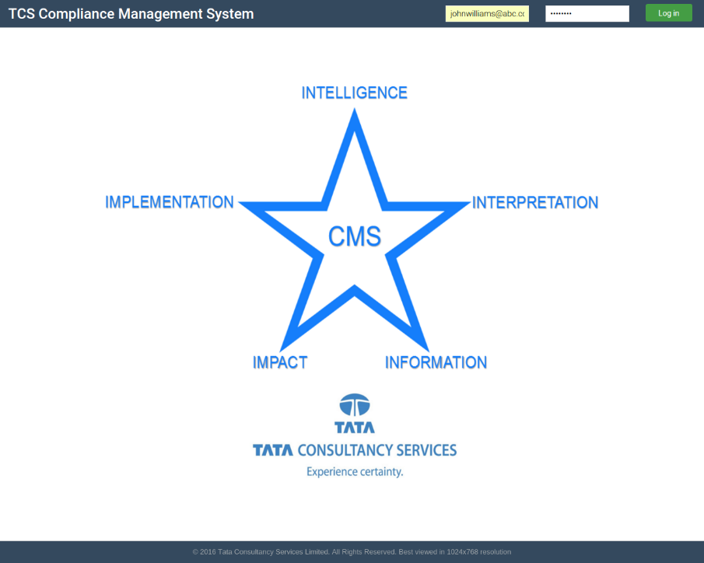

Figure 1: CMS Login Page

1. Enter your login id (your registered e-mail id) and password at the top right fields in the login page.
2. Click on the login button.



**Figure 2: Entering Login credentials**

1. In case of incorrect credentials being entered, a flash message will pop-up describing the same.

**Figure 3: Incorrect credentials flash**

1. If the correct credentials are entered, you'll be redirected to the home page.

## Using the Interface

This section introduces you to the screen elements (workspace, navigation menu and common icons and buttons) you can use to interact with the CMS tool and perform various tasks and operations.

## Using the Sidebar and workspace buttons

This section introduces you to the screen elements (navigation sidebar and common icons and buttons) you can use to interact with the CMS tool and perform common activities.

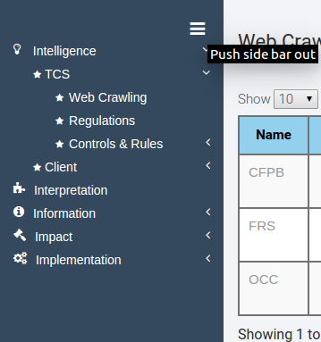You can click through different tabs and sub tabs in the sidebar to open and switch across different CMS modules.

**Figure 4: Sidebar opened.**

You can also click the button at the top of the sidebar to push the sidebar out to gain more workspace area.

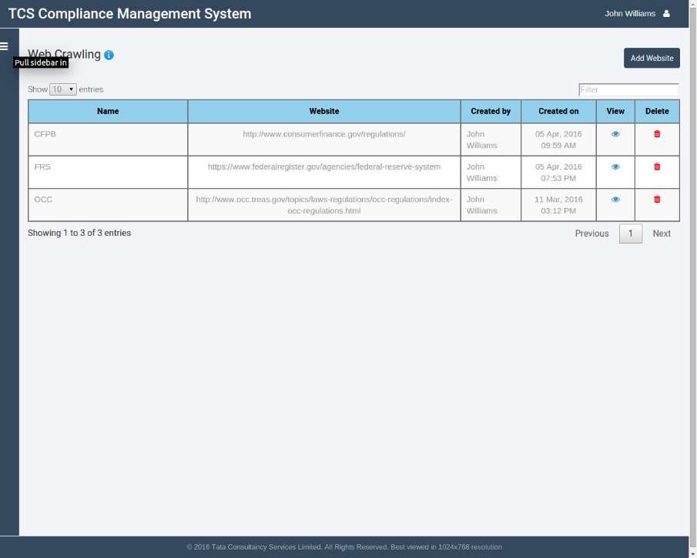

**Figure 5: Sidebar retracted.**

The following table lists common icons used across CMS:

|  |  |
| --- | --- |
| **Action** | **Icon** |
| View |  |
| Edit |  |
| Delete |  |
| Execute |  |
| Update |  |

Table 4: Common icons and corresponding actions

## Logging Out

**To log out from CMS tool:**

In the Home page, click upon the user account fieldat the top right corner of the CMS Home page and click on **Logout** in the subsequent dropdown. The CMS Login page appears.

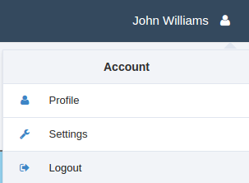

**Figure 6: Logging out from CMS.**

# Intelligence

This tab of the application deals with handling regulation and policy documents and their corresponding controls and rules. All standard regulations which are non-specific to a particular organisation and can be used across different organisations in a particular domain fall under the TCS section. TCS reserves the right to deploy these documents on different installation environments.

On the other hand, all policy documents internal and specific to a particular client fall under the client section. These are internal to the client and are stored locally only at the client installation site.

Specific controls and rules can be set up for both regulation and policy documents.



## Web Crawling

This page provides a list of downloadable links so that a user can then select one to download and store a regulation document in the system.

The table shows the name of the website, the URL, and the details about who created the entry and at what date and time. There are options to view the downloadable links inside and delete the entry altogether.

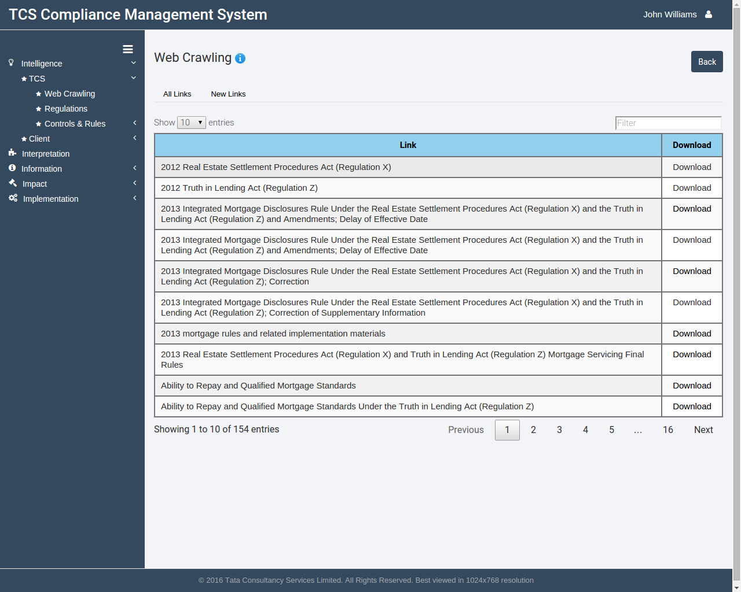

Figure 7: Web Crawling Page

## Adding a new website

* + - 1. Go to Intelligence>TCS>Web Crawling by clicking corresponding icons in the sidebar.
      2. Click on the **Add website** button at the top right corner of the window, below the user account dropdown.

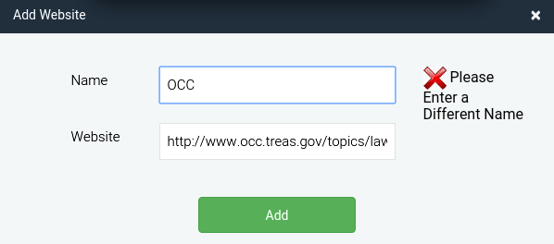

Figure 8: Adding a new website

* + - 1. A modal window will open. Enter a unique name and a URL not present in the list already and click on the **Save** button. The website details will get added in the repository.

## Viewing links under a website

* + - 1. Click the View button against the website you want to see.



Figure 9: List of download-able regulations

* + - 1. A list of all downloadable documents will be shown to you.
      2. Click the **Download** button against a document to download it.
      3. A modal window will open. Enter a name and identifier version for the regulation.

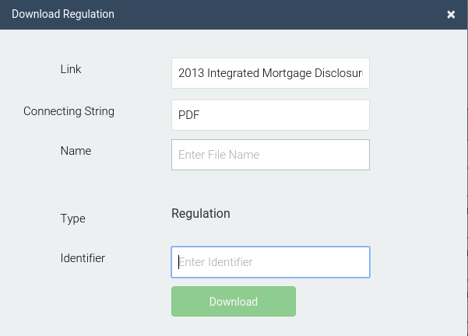

Figure 10: Download regulation modal

* + - 1. Click on the **Download** button to download the regulation and store it in the repository

## Regulations

This page lists all regulation documents that have been stored in the repository. This, in essence, provides a manual way to upload offline regulation documents apart from adding them via web-crawler.

The table mentions the name of the regulation, the type, the identifier (which is used to distinguish between different versions of the same regulation, and options to update, edit or delete the regulation).

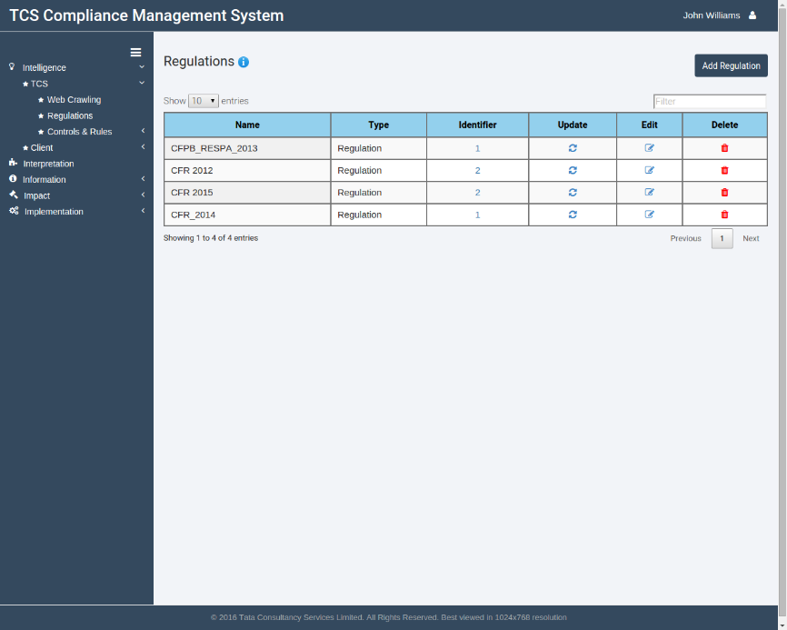

Figure 11: Regulations Page

## Adding a new regulation

* + - 1. Go to Intelligence>TCS>Regulations by clicking corresponding icons in the sidebar.
      2. 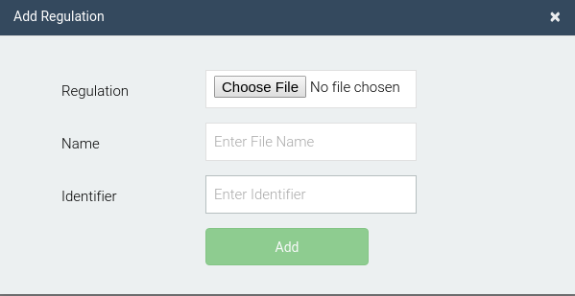Click on the **Add** **Regulation** button at the top-right corner, below the user account dropdown.

Figure 12: Adding a new regulation

* + - 1. A modal window will open. Select a file from the choose file dialog, provide a unique name and an identifier version for that document. Click on the **Add** button to add the document in the repository.

## Edit a regulation document

* + - 1. 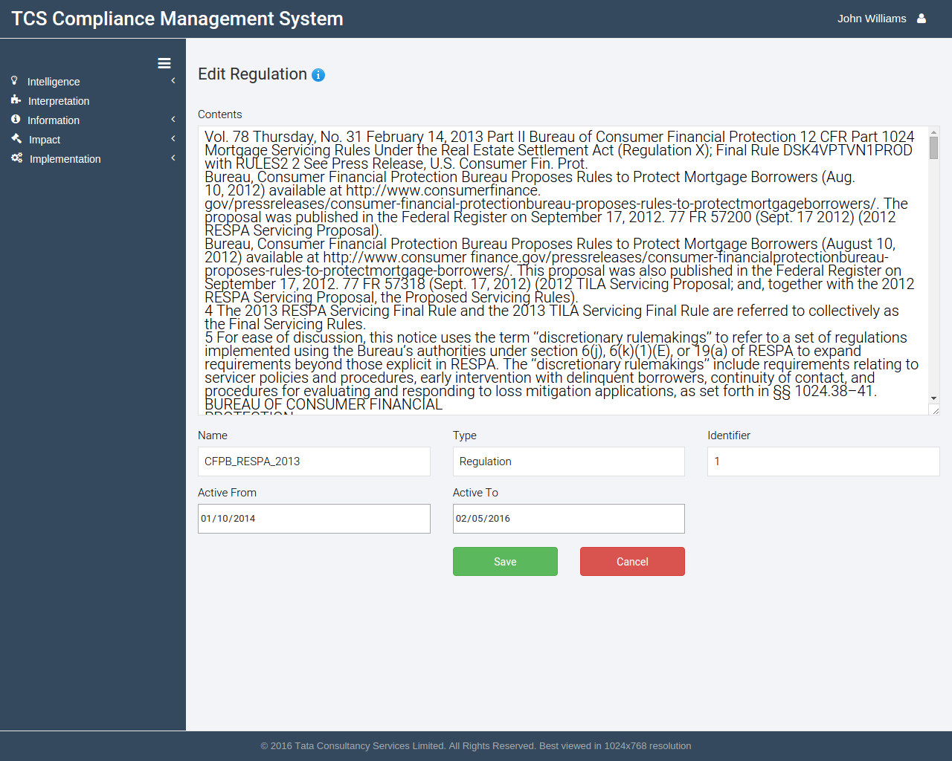Click on the edit button against the regulation which you want to edit.

Figure 13: Edit Regulation

* + - 1. The regulation text and corresponding details would be shown in the following page.
      2. After you're done editing the regulation, click on the **Save** button to save the edited document or cancel to discard the changes.

## Update a regulation document

* + - 1. Click on the Update button against the regulation whose document file has to be updated.

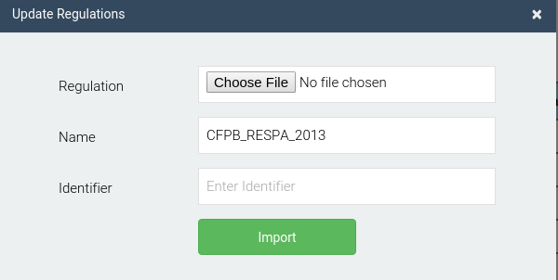

Figure 14: Update Regulation

* + - 1. A modal window will open. Select the regulation document using the choose file dialog, and the new identifier number and click on the **Import** button to update the regulation on the repository.

## Viewing identifier history of a document

* + - 1. Click on the identifier button against the regulation for which the identifier history has to be seen.

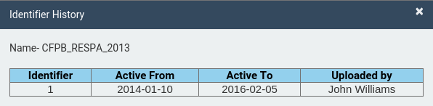

Figure 15: Regulation identifier history

* + - 1. The resulting modal will display all previous version history of the document.

## TCS Controls

This page lists all controls based upon regulations stored in the repository. The table lists the name, business, category, risk type, a brief description of the control and the regulation name it is associated, with options to edit and delete the control.

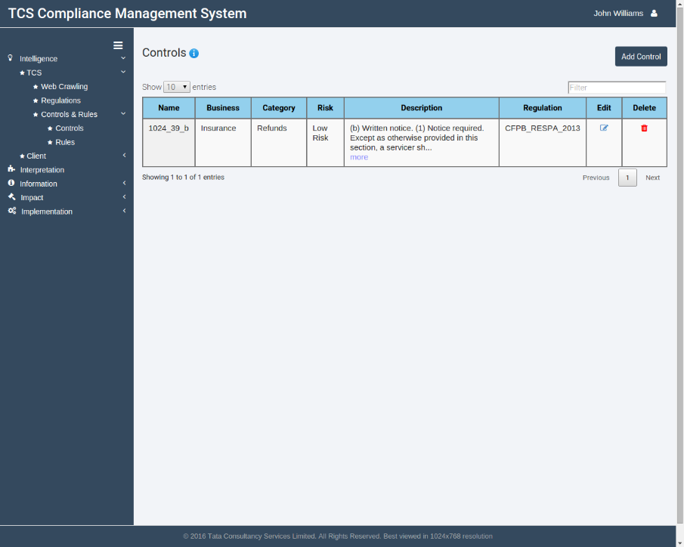

Figure 16: TCS Controls page

## Adding a new control

* + - 1. Go to Intelligence>TCS>Controls & Rules>Controls by clicking corresponding icons in the sidebar.
      2. Click on the **Add** **Control** button at the top right corner, below the user account dropdown.
      3. A modal window will open. Enter a unique name, select suitable types for Business, Category and Risk. Select dates from/to which the control will be active and provide a suitable description.
      4. To link the control to a regulation document, select 'Yes' in the Link regulation radio box and select the regulation to which it has to be attached to. Select the section(s) which have to be associated with the control.
      5. Click on the **Add** button to save the control in the repository.

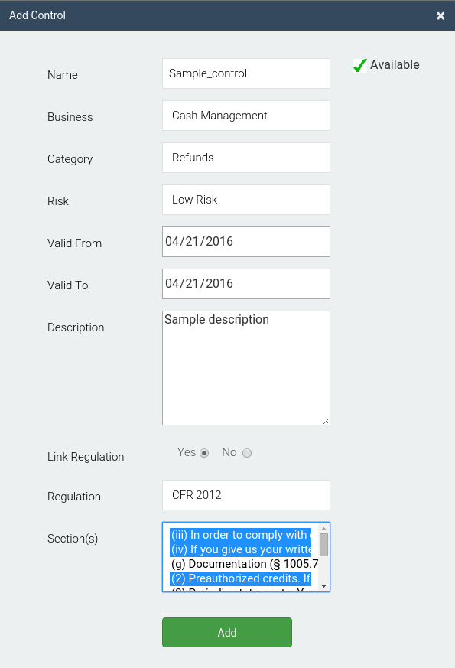

Figure 17: Adding a control

## Editing a control

* + - 1. Click on the Edit button against the control to be edited.

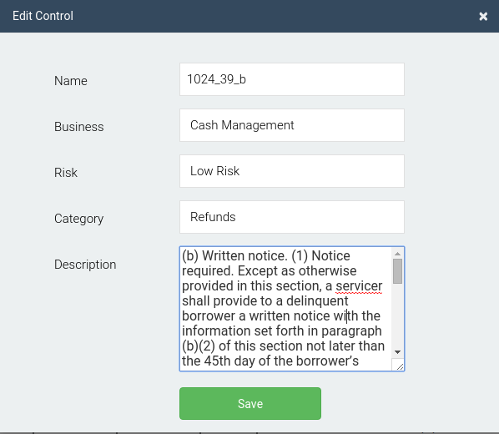

Figure 18: Editing a control

* + - 1. A modal window will open. Update necessary details and click on the **Save** button to update the control in the repository. Note that the name of the control can't be edited.

## TCS Rules

This page lists all rules based upon a control of a regulation. The table lists the name and description of a rule, the type, the parent rule and control and any rule specific values which might be present for a particular standard attribute and options to edit and delete the rules.

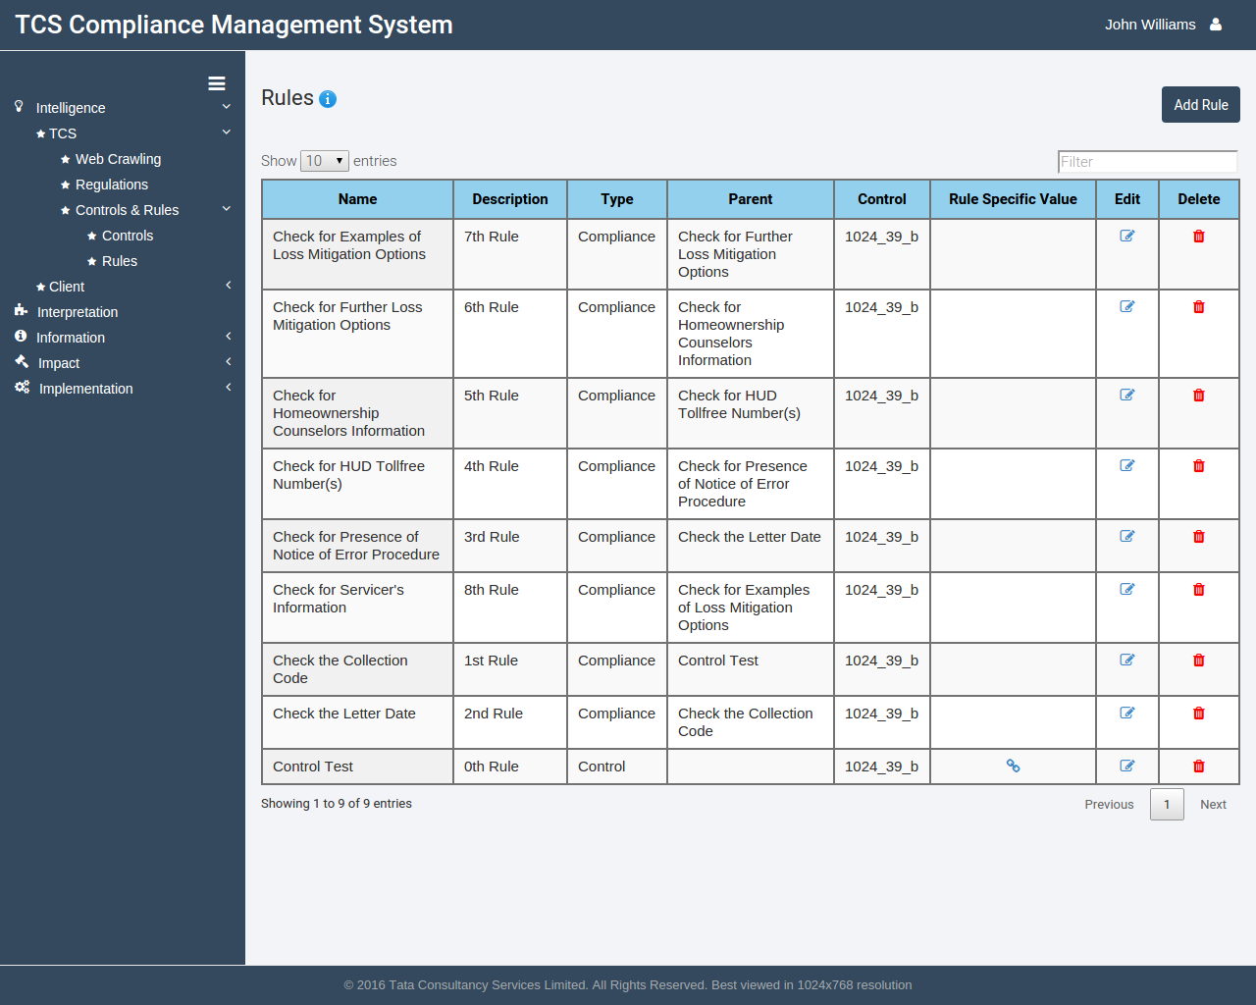

Figure 19: TCS Rules Page

## Adding a new rule

* + - 1. Go to Intelligence>TCS>Controls & Rules>Rules by clicking corresponding icons in the sidebar.
      2. Click on the **Add rule** button at the top right corner below the user account dropdown.
      3. A modal window will open. Enter a unique name for the rule and select the type and the control to link it with. Provide suitable text for description and click on the **Add rule** button. The rule will be saved in the repository.

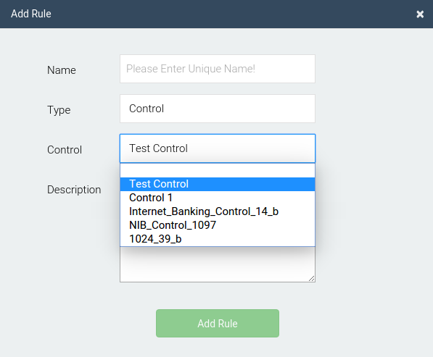

Figure 20: Add rules modal

## Editing a rule

* + - 1. Click on the edit rule button against the rule to be edited.

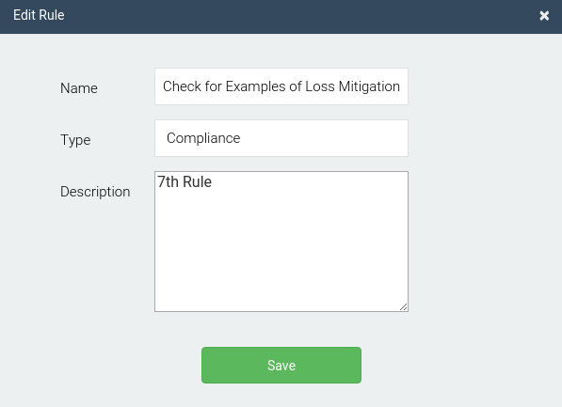

Figure 21: Edit rules modal

* + - 1. Edit the type/description and click on the **Save** button. The updated rule will be saved in the repository.

Note that the name of the rule can't be edited.

## Folder Crawling

This page provides a list of servers so that a user can then select one to execute and upload a policy document in the system.

The table lists the name of a server, its IP address, the path to be crawled, the port number to connect with, username and options to execute the crawling and to edit/delete the folder.

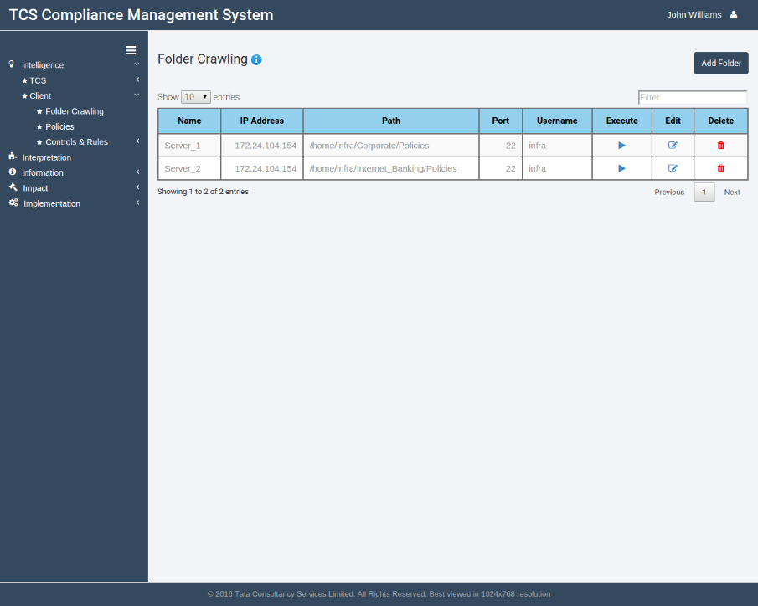

Figure 22: Folder crawling page

## Adding a new folder

* + - 1. Go to Intelligence>Client>Folder Crawling by clicking corresponding icons in the sidebar.
      2. Click on the add folder at the top right under the user account dropdown.
      3. A modal window will open. Enter name, IP address of the server to connect, the folder path to access, port number (generally 22), and the server username and password.
      4. Click on the **Add** button to save to the repository.

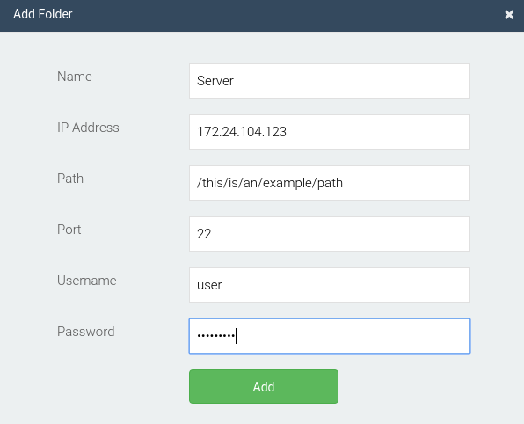

Figure 23: Add folder modal

## Executing folder crawling

* + - 1. Click on the execute button against the folder you want to extract policy documents from.
      2. The documents will be uploaded to the server and you’ll be redirected back to the same page.

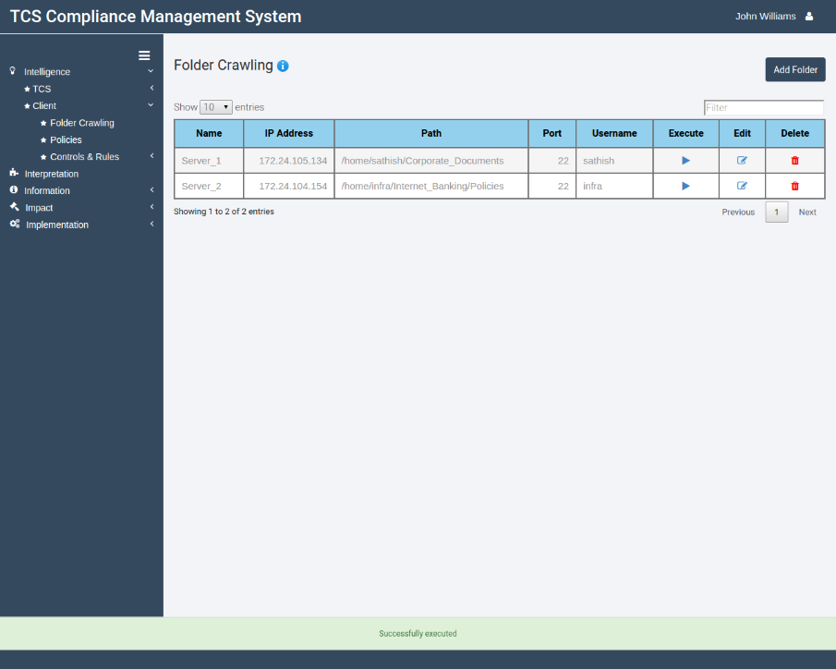

Figure 24: Execute folder crawl

## Editing a folder crawl

* + - 1. 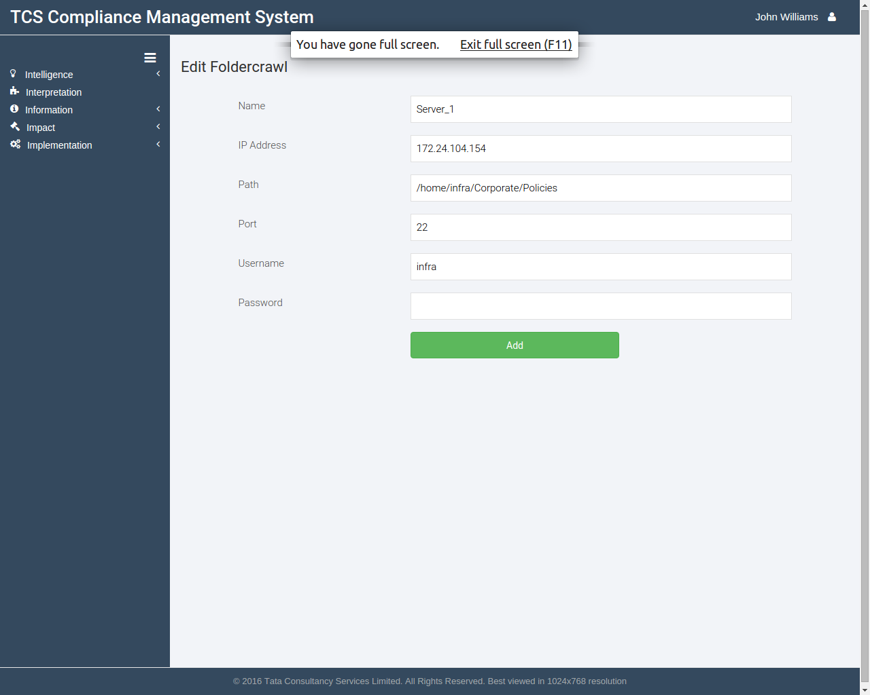Click on the edit button against the folder you want to edit.

Figure 25: Edit folder crawl

* + - 1. Enter updated details for the folder and then click on Add. The folder details will be updated in the application.

## Policies

This page lists all policy documents that have been stored in the repository. This, in essence, provides a manual way to upload offline policy documents apart from adding them via folder-crawler.

The table mentions the name of the policy, the type, the identifier (which is used to distinguish between different versions of the same policy, and options to update, edit or delete the policy).

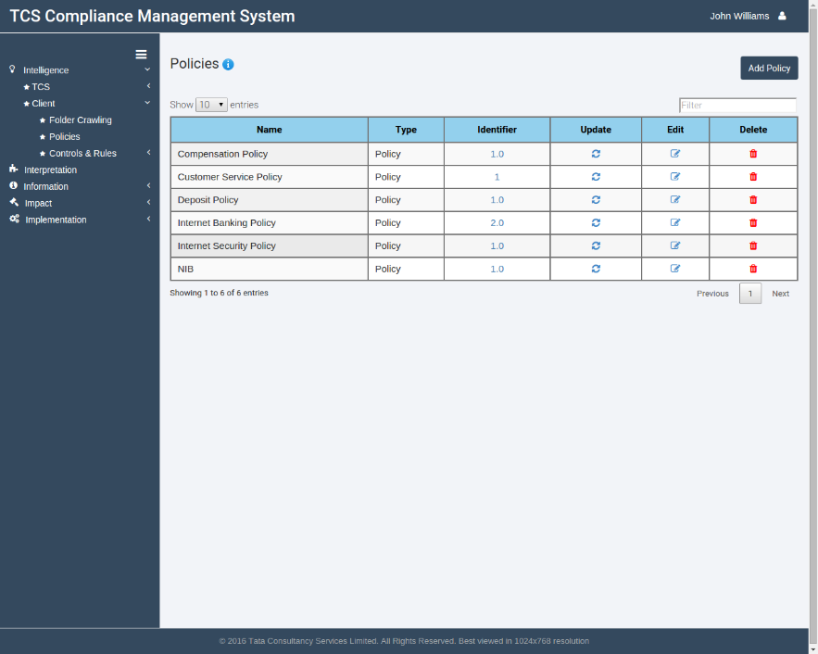

Figure 26: Policies page

## Adding a new policy

* + - 1. Go to Intelligence>Client>Policies by clicking corresponding icons in the sidebar.
      2. Click on the **Add Policy** button at the top-right corner, below the user account dropdown.

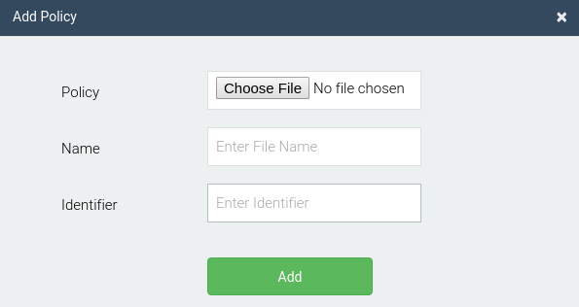

Figure 27: Add policy modal

* + - 1. A modal window will open. Select a file from the choose file dialog, provide a unique name and an identifier version for that document. Click on the **Add** button to add the document in the repository.

## Edit a policy document

* + - 1. Click on the edit button against the policy which you want to edit.

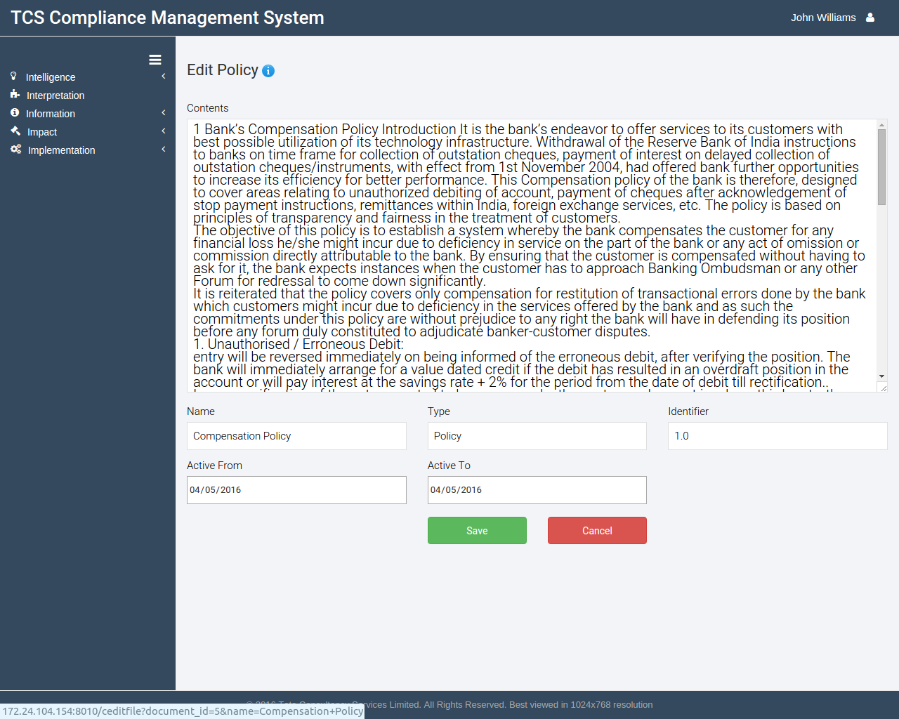

Figure 28: Edit policy

* + - 1. The policy text and corresponding details would be shown in the following page.
      2. After you've done editing the policy, click on the **Save** button to save the edited document or cancel to discard the changes

## Update a policy document

* + - 1. Click on the Update button against the policy whose document file has to be updated.

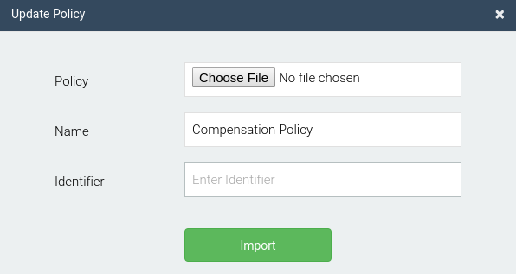

Figure 29: Update policy

* + - 1. A modal window will open. Select the policy document using the choose file dialog, and the new identifier number and click on the **Import** button to update the policy on the repository.

## Viewing identifier history of a document

* + - 1. Click on the identifier button against the policy for which the identifier history has to be seen.

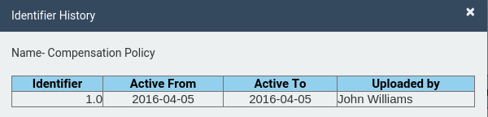



Figure 30: Policy identifier history

* + - 1. The resulting modal will display all previous version history of the document.

## Client controls

This page lists all controls based upon policies stored in the repository. The table lists the name, business, category, a brief description of the control, with options to edit and delete the control.

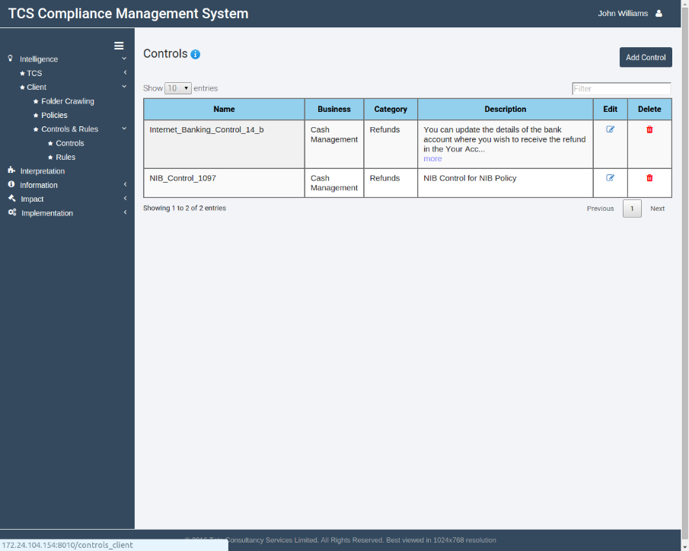

Figure 31: Client controls page

## Adding a new control

* + - 1. Go to Intelligence>Client>Controls & Rules>Controls by clicking corresponding icons in the sidebar.
      2. Click on the **add control** button at the top right corner, below the user account dropdown.

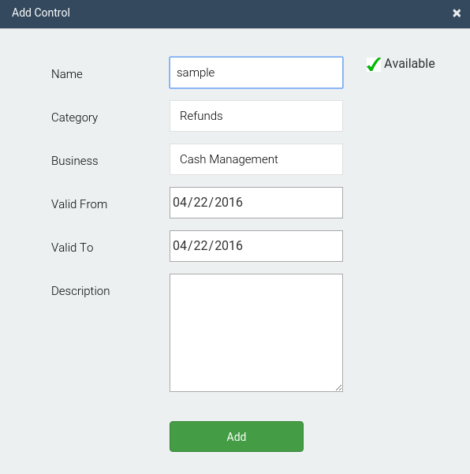

Figure 32: Add client control modal

* + - 1. A modal window will open. Enter a unique name, select suitable types for Business and Category. Select dates from/to which the control will be active and provide a suitable description.
      2. Click on the **Add** button to save the control in the repository.

## Editing a control

* + - 1. Click on the Edit button against the control to be edited.
      2. A modal window will open. Update necessary details and click on the **Save** button to update the control in the repository.

Note that the name of the control can't be edited.

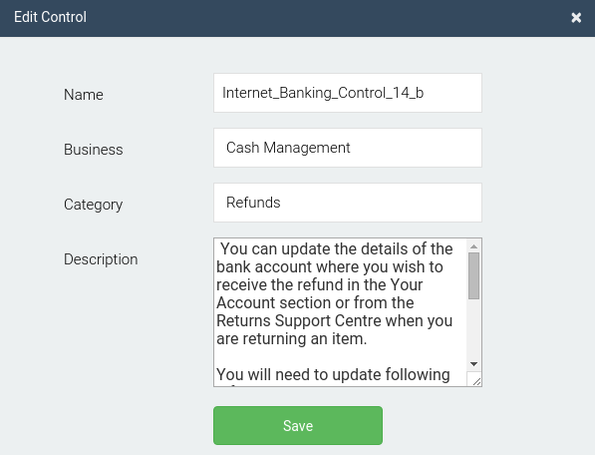

Figure 33: Edit client control modal

## Client rules

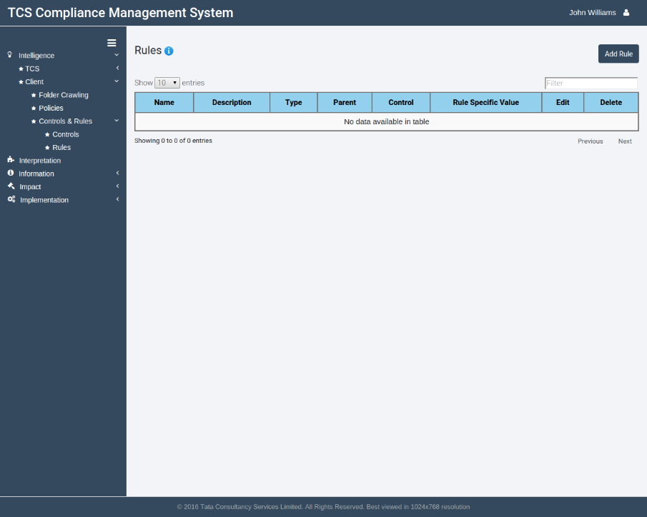This page lists all rules based upon a client control. The table lists the name and description of a rule, the type, the parent rule and control and any rule specific values which might be present for a particular attribute and options to edit and delete the rules.

Figure 34: Client rules page

## Adding a new rule

* + - 1. Go to Intelligence>Client>Controls & Rules>Controls by clicking corresponding icons in the sidebar.
      2. 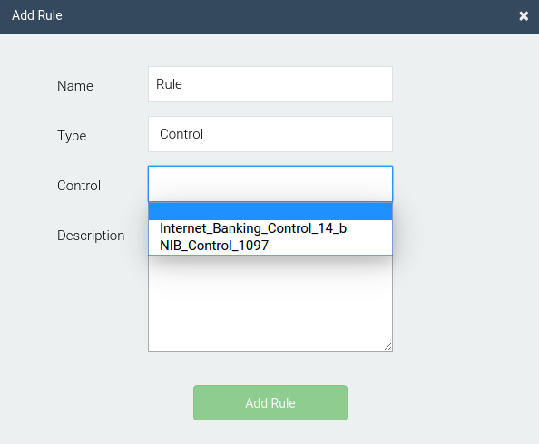Click on the **Add rule** button at the top right corner below the user account dropdown.

Figure 35: Add rule modal

* + - 1. A modal window will open. Enter a unique name for the rule and select the type and the control to link it with. Enter suitable description.
      2. Click on the **Add rule** button. The rule will be saved in the repository.

## Editing a rule

* + - 1. Click on the edit rule button against the rule to be edited.



Figure 36: Edit rule modal

* + - 1. Edit the type/description and click on the **Save** button. The updated rule will be saved in the repository. Note that the name of the rule can't be edited.

# Interpretation

CMS allows the user to easily get the crux of a document without going deep into the domain specific jargons. Thus, new regulation/policy documents can easily be converted into controls and rules in real quick time. This tab is currently a Work In Progress (WIP) section.

# Information

This tab is responsible for storing all customer data. Sub-tabs here are segregated again as TCS and client. Under TCS, generic attributes are stored as standard attributes. Rules are created over these attributes. Under the client section, client attributes are stored and can vary depending upon the organization. These attributes can be mapped together in the common section.

Also, all client data is stored under data extraction tab. CMS provides variety of ways to input client data. These are: OCR, Web scripts, Mainframe scripts, Desktop scripts, extraction from Word/PDF documents, ETL from a database and manual data input.

A workflow is maintained to help keep track of all sources where data enters the application. The user can later approve or reject the input data.

All customer names for which compliance has to be ensured are stored in the Keys in the client sub-tab.



## Standard Attributes

The standard attributes page list different attributes that are commonly used across a particular domain. The attributes names are generic in nature and are intended to be used while declaring rules. The table lists the names of attributes, description and provides options to edit and delete the attributes.

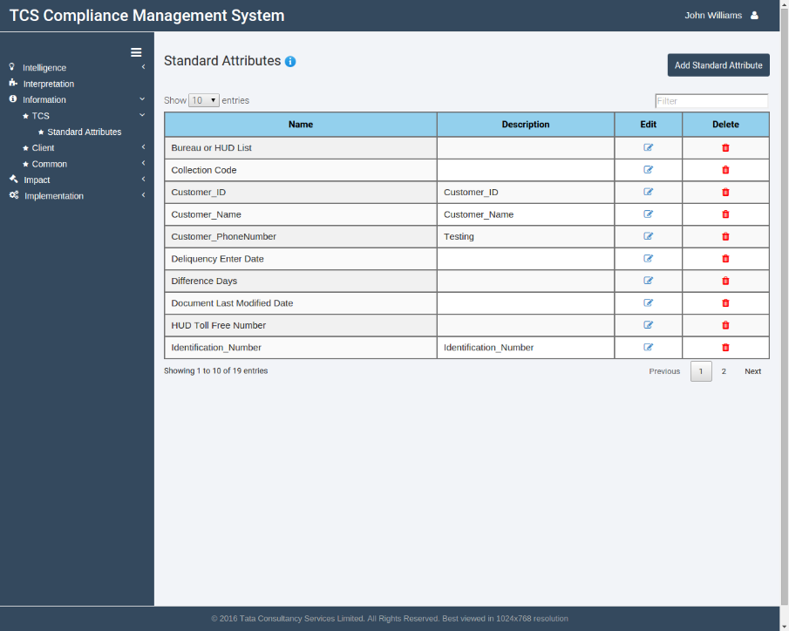

Figure 37: Standard attributes page

## Adding new standard attributes

* + - 1. Go to Information>TCS>Standard Attributes by clicking corresponding icons in the sidebar.
      2. Click on the **Add** **Standard** **Attribute** button at the top right, under the user account dropdown.

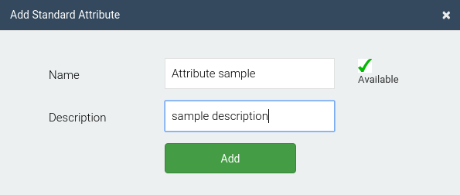

Figure 38: Add Standard attribute modal

* + - 1. A modal window will open. Provide a unique name and enter a description.
      2. Click on Add to save the new standard attribute.

## Editing standard attributes

* + - 1. Click on the edit button against the standard attribute to be edited.
      2. A modal window will open. Edit the description.

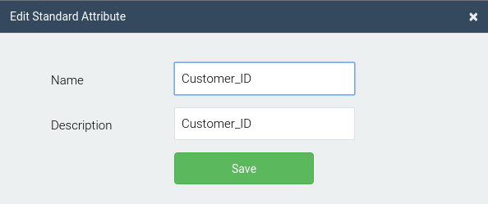

Figure 39: Edit Standard attribute modal

* + - 1. Click on the **Save** button to save the attribute

## Keys

This page lists the details of customers/records for which the organization wants to ensure compliance. All customer details need to be saved under keys so that rule execution for a particular result can be performed for a particular customer. The table lists the name of the key, description and options to edit and delete the key.

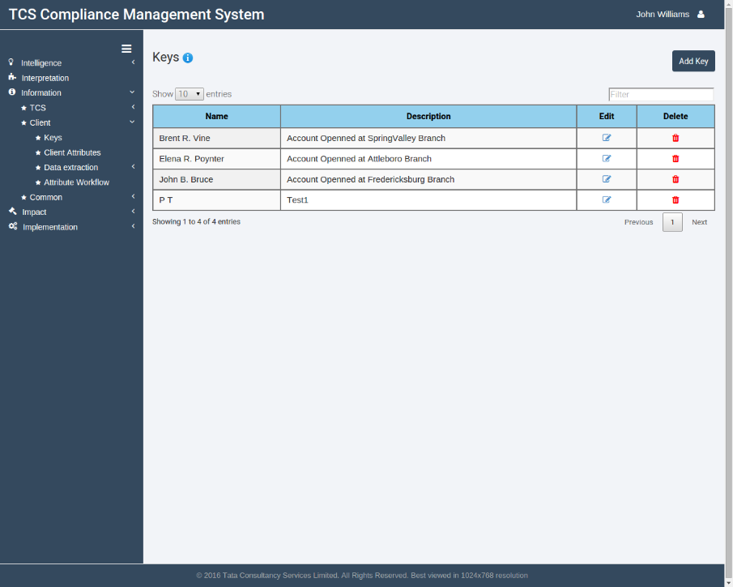

Figure 40: Keys page

## Adding a new key

* + - 1. Go to Information>Client>Keys by clicking corresponding icons in the sidebar.
      2. Click on the **Add** **key** button at the top right, under the user account dropdown.

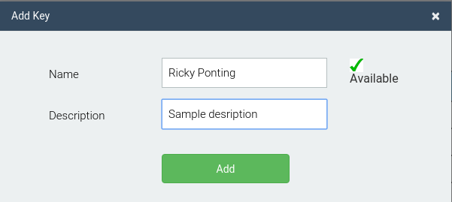

Figure 41: Add key modal

* + - 1. A modal window will open. Enter a unique name and the description for the new key.
      2. Click on Add to store the key into the application.

## Editing a key

* + - 1. Click on the edit button against the key name to be edited.

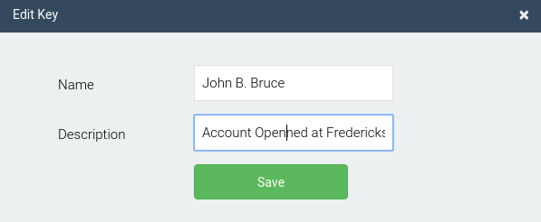

Figure 42: Edit key modal

* + - 1. A modal window will open. Edit the name/description and click on Save to save the key details.

## Client Attributes

The client attributes page list different attributes that are used by a particular organization. The attributes names are generally a slight variation of standard attributes. The organization is free to use any client attribute names and link them with the corresponding standard attribute.

The table lists the names of attributes, description, the source and process names, and provides options to view the usage of the attribute and to edit and delete the attributes.

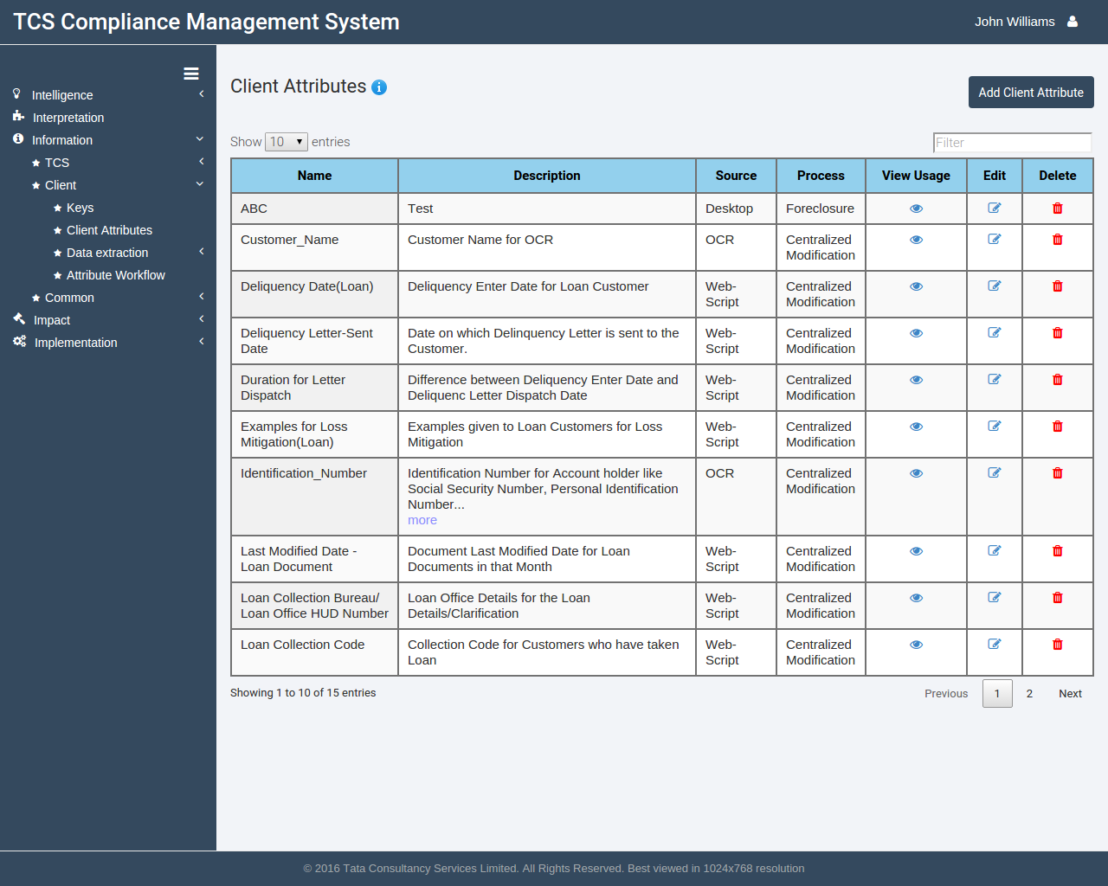

Figure 43: Client attributes page

## Adding a new Client Attribute

* + - 1. Go to Information>Client>Client Attributes by clicking corresponding icons in the sidebar.
      2. Click on the **Add** **Client** **Attribute** button at the top right, under the user account dropdown.

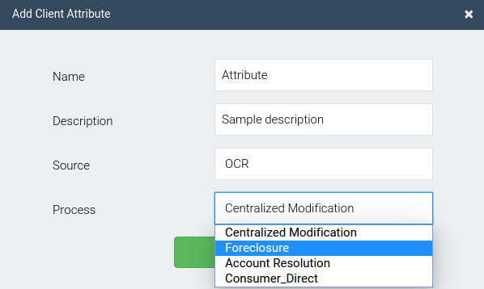

Figure 44: Add client attribute modal

* + - 1. A modal window will open. Provide a unique name and enter a description.
      2. Select the source and the process names from the corresponding drop-downs.
      3. Click on Add to save the new client attribute.

## Editing a Client Attribute

* + - 1. Click on the edit button against the client attribute to be edited.

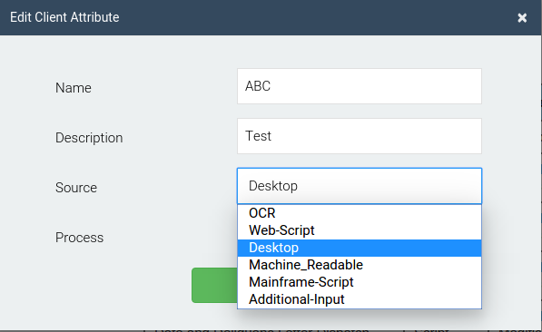

Figure 45: Edit client attribute modal

* + - 1. A modal window will open. Edit the description and/or change the source and process.
      2. Click on Save to save the attribute.

## Data extraction

TCS Compliance Management System provides the user a variety of ways to input customer data into the system. The user can input bulk customer data and can then check for compliance to various controls and rules.

The following are the data extraction techniques available in CMS:

* OCR
* Web Scripts
* Mainframe Scripts
* Desktop Scripts
* Word/PDF
* Additional Input
* ETL

## OCR

The OCR technique allows the user to extract data from scanned documents. The user has to input a template document which specifies the coordinates of attributes in an input sheet. Once the template is stored, the user can then execute it for different keys to extract those attributes. The table lists the name of the OCR template, the user name who created the template, and options to execute, view and delete the template.

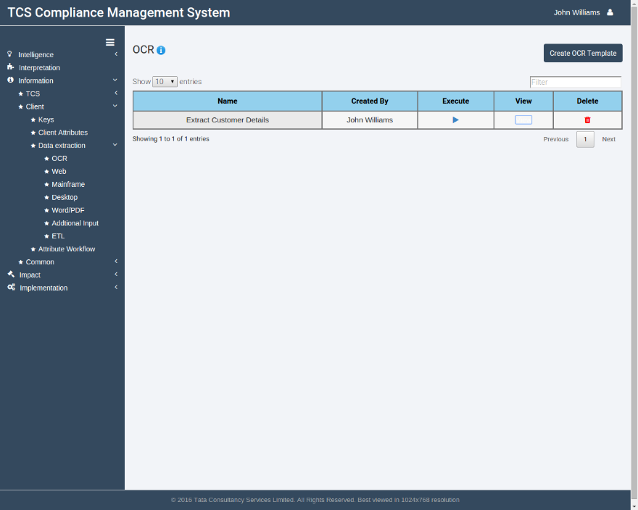

Figure 46: OCR page

## Creating a new OCR template

* + - * 1. Go to Information>Client>Data Extraction>OCR by clicking corresponding icons in the sidebar.
        2. Click on the **Create OCR template** button at the top-right, under the user account dropdown.

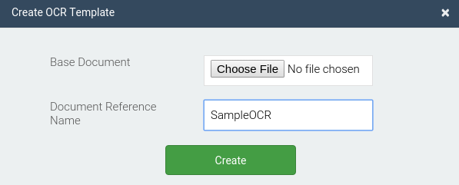

Figure 47: Create OCR template modal

* + - * 1. A modal window will open. Select a sample base document from the file selector and provide a valid reference name.
        2. Click on the **Create** button to create the OCR template.

## Viewing an existing OCR template

* + - * 1. Click on the View button against the template whose details you wish to view.
        2. The resultant modal window will describe all attributes and their coordinates in a tabular format.

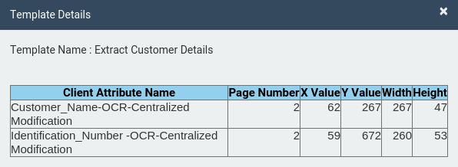

Figure 48: OCR template details modal

* + - * 1. Here page number specifies the page number of the base document where the attribute would be found. X & Y values are the starting coordinates and the width and height refer to the width and height of the area where the attribute lies.

## Executing a template

* + - * 1. Click on the Execute button against the template to be executed.

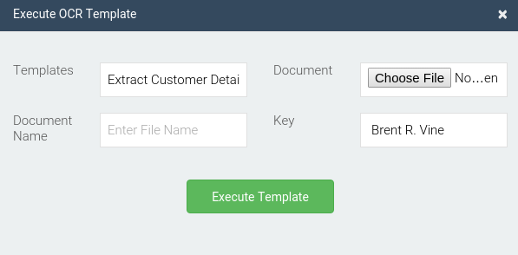

Figure 49: Execute OCR template modal

* + - * 1. A modal window will open. Select the document on which the template has to be executed using the file selector and provide a valid name for the same.
        2. Select the key for which the data is being extracted using the drop down list.
        3. Click on the **Execute Template** button. The data would be read and stored into the application.

## Web Scripts

Web Scripts allow the user to extract customer data using a web application. The user needs to specify the script path to be executed and the input and output client attribute names. The table lists the names of different saved scripts with options to edit, execute or delete the script.

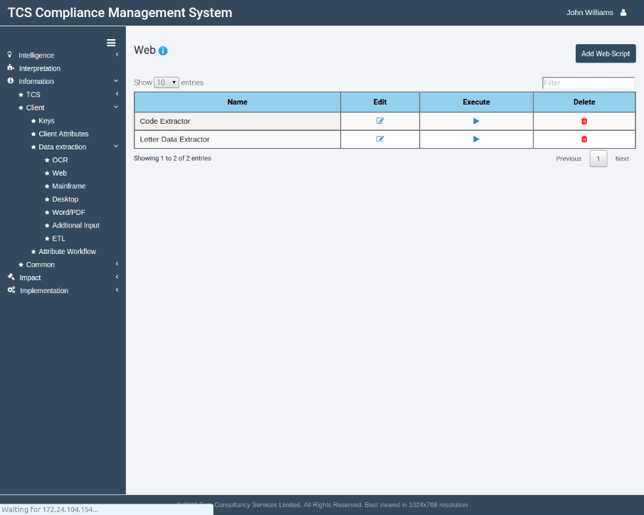

Figure 50: Web Scripts page

## Adding a new web script

* + - * 1. Go to Information>Client>Data Extraction>Web by clicking corresponding icons in the sidebar.
        2. Click on the **Add Web-script** button at the top-right, under the user account dropdown.

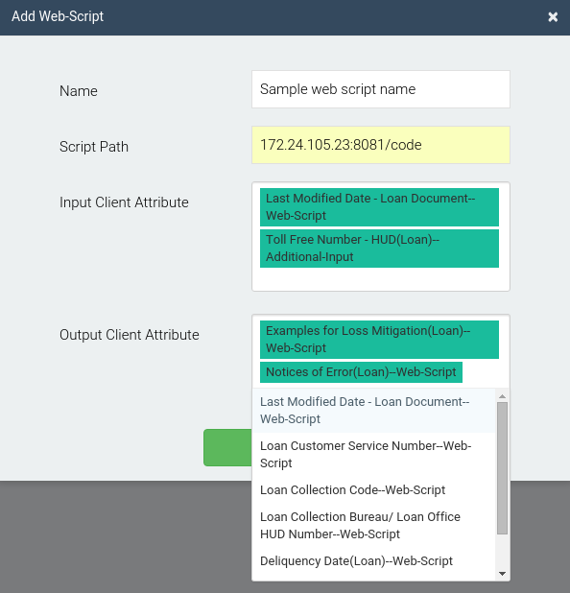

Figure 51: Add web script modal

* + - * 1. A modal window will open. Enter a unique name for the script and the path where the script has to be executed from.
        2. Select input and output client attributes from the multi-select drop down lists.
        3. Click on the **Create** button to create the web script.

## Editing a web script

* + - * 1. Click on the edit button against the script to be edited.
        2. A modal window will open. Edit the fields to be edited and select the required client attributes from the multi select drop down lists.
        3. Click on the **Save** button to update the Web script.

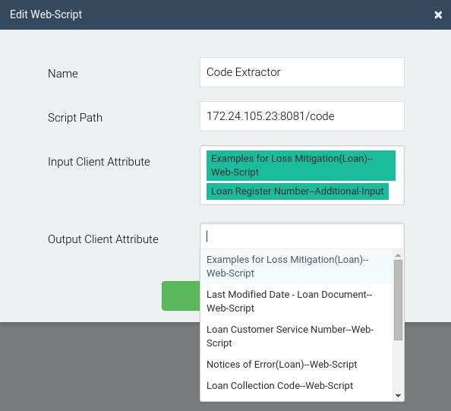

Figure 52: Edit web script modal

## Executing a web script

* + - * 1. Click on the execute button against the script to be executed.

Figure 53: Execute web script modal

* + - * 1. Select the key(s) for which the script has to be executed from the multi select drop down list.
        2. Click on the **execute** button to execute the web script.

## Mainframe Scripts

Mainframe Scripts allow the user to extract customer data using a mainframe screen. The user needs to specify the script path to be executed and the input and output client attribute names. The table lists the names of different saved scripts with options to edit, execute or delete the script.

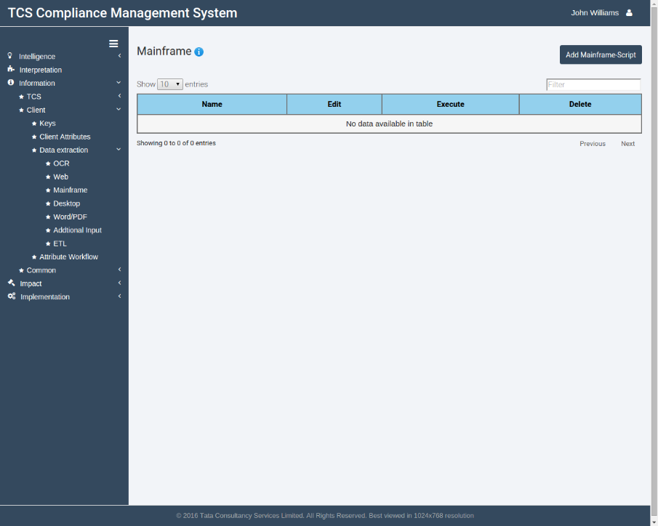

Figure 54: Mainframe script page

## Adding a new mainframe script

* + - * 1. Go to Information>Client>Data Extraction>Mainframe by clicking corresponding icons in the sidebar.
        2. 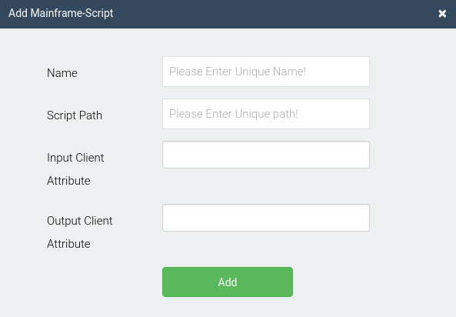Click on the **Add** **Mainframe**-**script** button at the top-right, under the user account dropdown.

Figure 55: Add Mainframe script modal

* + - * 1. A modal window will open. Enter a unique name for the script and the path where the script has to be executed from.
        2. Select input and output client attributes from the multi-select drop down lists.
        3. Click on the **Add** button to create the mainframe script.

## Editing a mainframe script

* + - * 1. Click on the edit button against the script to be edited.

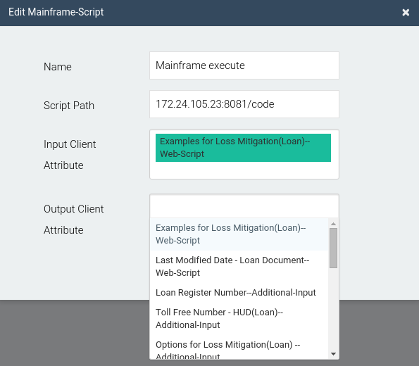

Figure 56: Edit Mainframe script modal

* + - * 1. A modal window will open. Edit the fields to be edited and select the required client attributes from the multi select drop down lists.
        2. Click on the **Save** button to update the Mainframe script.

## Executing a mainframe script

* + - * 1. Click on the execute button against the script to be executed.

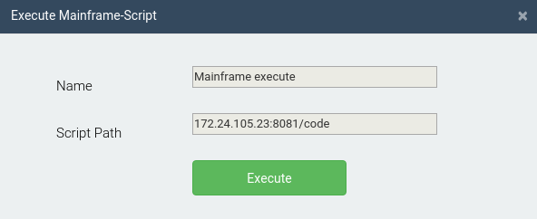

Figure 57: Execute Mainframe script modal

* + - * 1. Click on execute to execute the Mainframe script.

## Desktop Scripts

CMS provides the user the ability to scrape through a desktop screen to extract customer data. This feature is currently under construction.

## Word/PDF

CMS provides the user the ability to process machine readable documents like Word/PDF documents to extract customer information. This feature is currently under construction.

## Additional Input

Apart from the different techniques discussed, CMS also provides an option to manually enter data for a key, in case a particular attribute cannot be read through any technique discussed previously. The table lists the key name for which data has been added, the client attribute name whose value was added, the source and process of the attribute. It also lists the original and modified values of the attribute, comments, and details about who added the data.

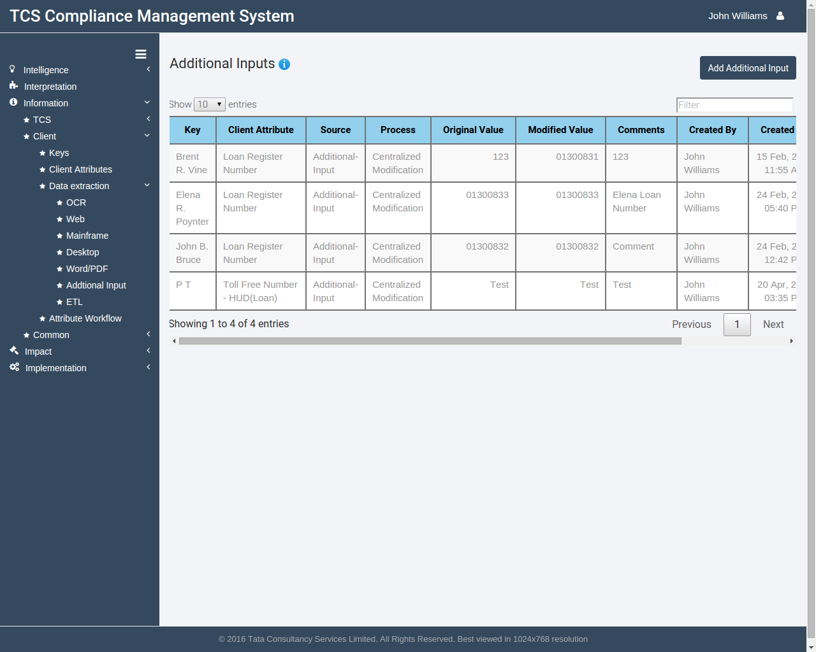

Figure 58: Additional Inputs page

## Adding new additional input

* + - * 1. Go to Information>Client>Data Extraction>Additional Input by clicking corresponding icons in the sidebar.
        2. Click on the Add Additional Input at the top right, below the user account dropdown.

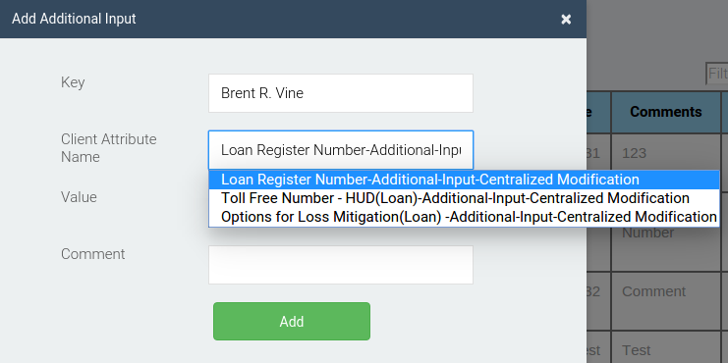

Figure 59: Adding new additional input

* + - * 1. A modal window will open. Select the key and client attribute names from the drop-downs.
        2. Enter the value for the attribute and provide suitable comments.
        3. Click on the **Add** button to save the attribute in the application.

## Modifying existing additional input value

* + - * 1. Click on the Modify button against the additional input value to be modified.
        2. A modal window will open listing the Key, the client attribute name and the original value of the attribute. Note that these fields are non-editable.
        3. Enter a new value for the attribute in the last text box.

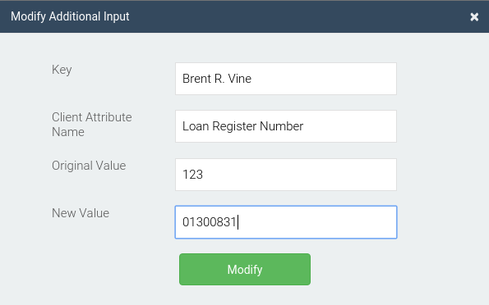

Figure 60: Modifying existing additional input

* + - * 1. Click on the **Modify** button to save the modified attribute value.

## ETL

CMS also provides an option to directly extract, transform and load data from an existing database. This feature is currently under construction.

## Attribute workflow

To keep track of all data being extracted, CMS provides a workflow to check the history of data extraction for a client attribute. Upon selecting a key, the user can then track the client attribute for which data was extracted, the source of data and the process, the original and the modified value. In case of certain sources, proof images and proof pages of the source will also be shown along with the user who extracted the data.

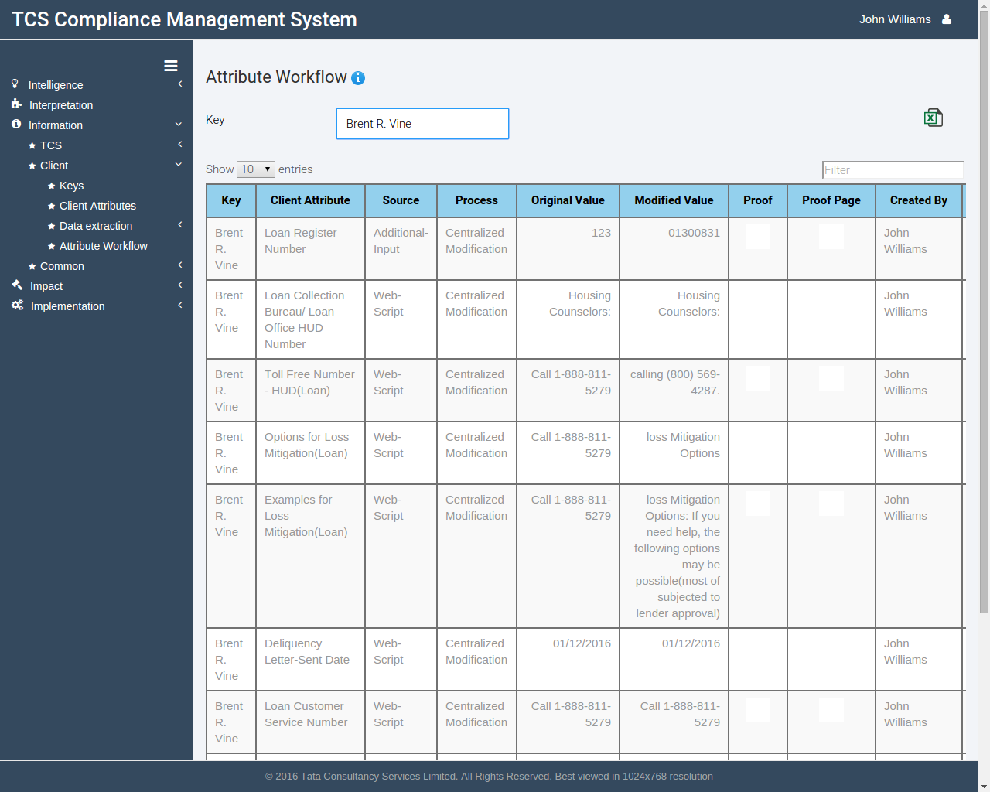

Figure 61: Attribute work flow page

## Using the Attribute work flow page

* + - 1. Select the key for which data workflow has to be tracked, using the drop down list at the top of the page.
      2. All previous data would be shown in the table.
      3. You can also export the data to an Excel sheet by clicking on the **Export to Excel** button at the top right below the user account dropdown.

## Link Attributes

All client attributes created in CMS have to be linked to a standard attribute, so that rules can be executed against them. The user is free to define client attributes with any name of their choice. However they need to link those attributes with corresponding standard attribute before rule execution is done on that attribute.

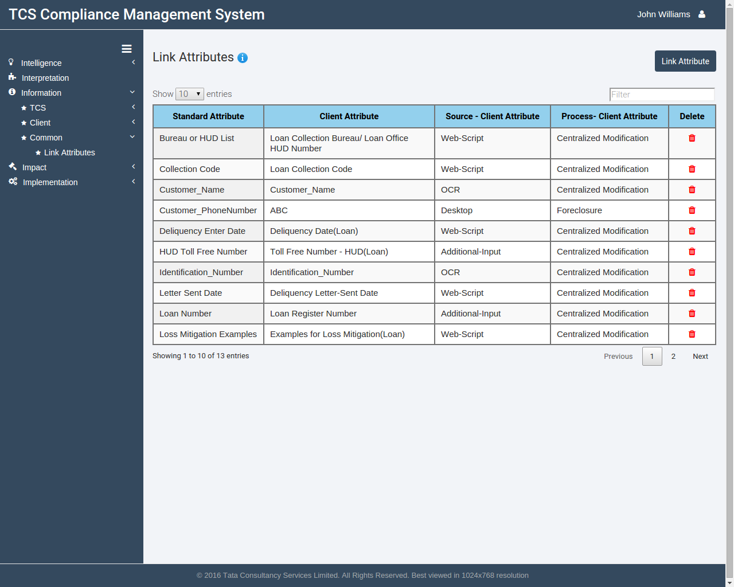

Figure 62: Link attributes page

## Linking Attributes

* + - 1. Go to Information>Common>Link Attributes by clicking corresponding icons in the sidebar.
      2. Click on the **Link** **attributes** button at the top right, below the user account dropdown.

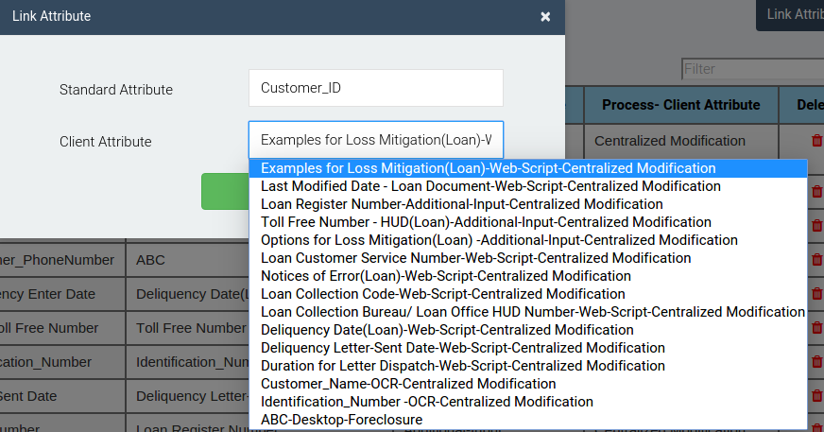

Figure 63: Link attributes modal

* + - 1. A modal window will open. Select the standard attribute and the client attribute names from the drop down lists.
      2. Click on the **Add** button to save in the application.

# Impact

This tab allows users to tag regulation and policy documents and their corresponding controls. The user can upload tag set files against which tagging of documents and controls can be done. Later, the user can check which sections of a document have an impact on different sections of other documents. Similarly, he/she can check which controls are affected by which sections of different documents and vice-versa.



## Tag Regulations

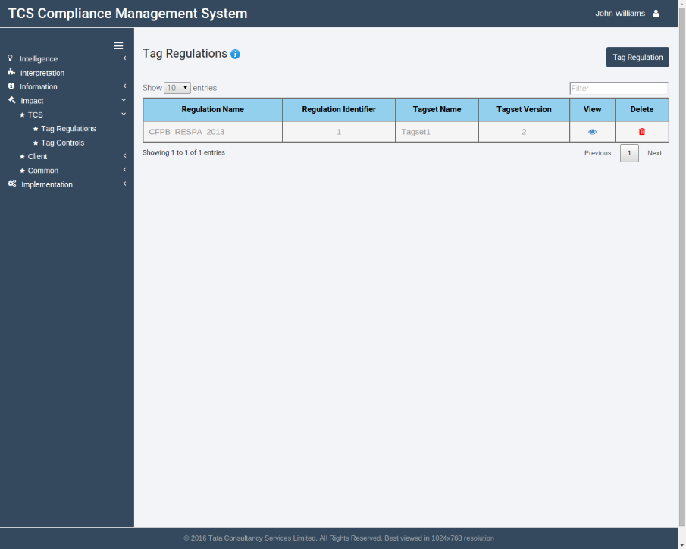CMS allows the user to tag regulation documents based upon a tag set file. Different section (paragraphs) of a regulation can be tagged in this page automatically. The user can also modify generated tags for each section. The table lists the regulation name, the regulation version number, the tag set used to tag the regulation, the corresponding tag set version number and options to view and delete the tagging.

Figure 64: Tag regulations page

## Tagging a Regulation

* + - 1. Go to Impact>TCS>Tag Regulations by clicking corresponding icons in the sidebar.
      2. Click on the **Tag** **Regulations** button at the top right, below the user account dropdown.

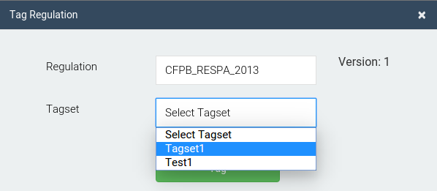

Figure 65: Tag regulation modal

* + - 1. Select the regulation name to be tagged. The latest version number available for the regulation will be displayed.
      2. Select a tag set file from the drop down list.
      3. Click on the **Tag** button to tag the regulation document.

## Viewing a tagged regulation

* + - 1. 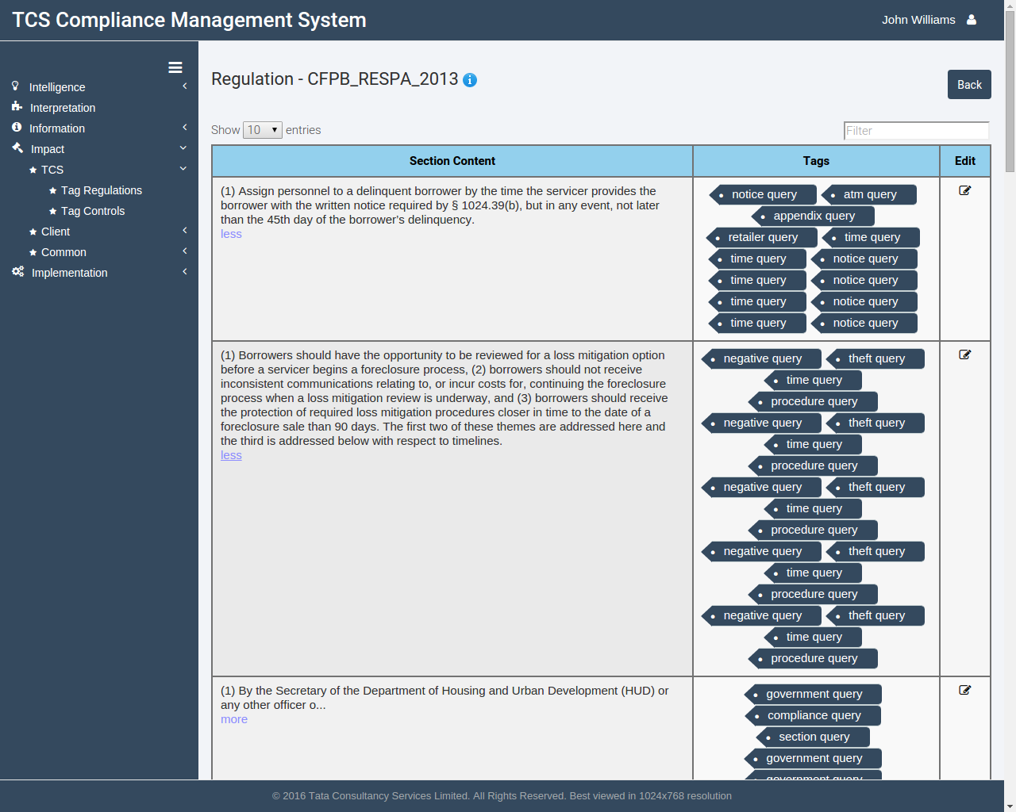Click on the View button against the regulation you want to see the tags for.

Figure 66: Viewing tags of regulations

* + - 1. The resultant page will list the regulation in tabular format, with each row showing a section (paragraph) of the regulation.
      2. Against each section, a list of tags auto-generated using CMS will be shown.

## Editing tags of a section

* + - 1. Click on the Edit button against the section whose tags have to be modified.

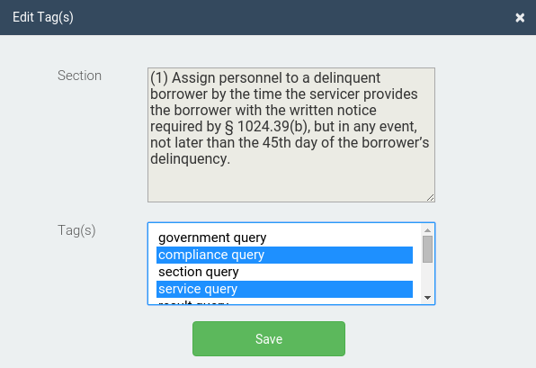

Figure 67: Edit regulation section tags modal

* + - 1. A modal window will open. Select the tags you wish to keep for the section using the multi select list.
      2. Click on the **Save** button to save the tags for the section.

## TCS Tag Controls

CMS allows the user to tag controls based upon a tag set file. All controls based upon a regulation can be tagged in this page automatically. The user can also modify generated tags for each control.

The table lists the control name, the tag set used to tag the control, the corresponding tag set version number, an option to edit the generated tags and option to delete the tagging.

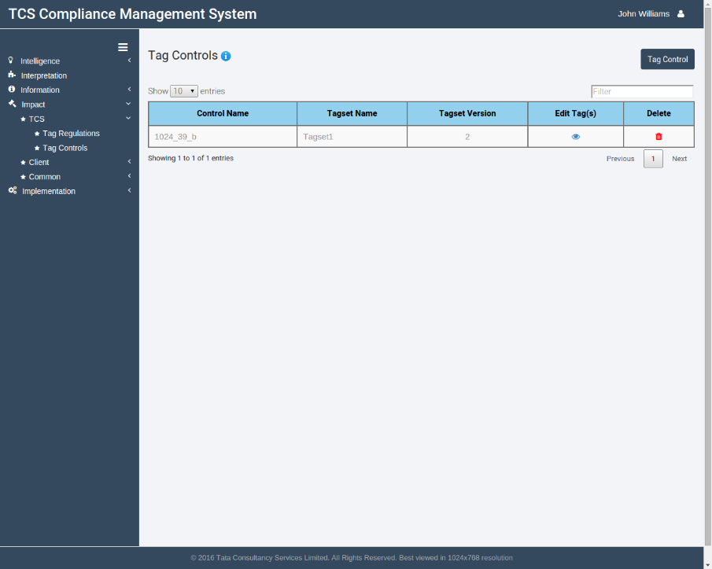

Figure 68: TCS Tag controls page

## Tagging a Control

* + - 1. Go to Impact>TCS>Tag Controls by clicking corresponding icons in the sidebar.
      2. Click on the **Tag Controls** button at the top right, below the user account dropdown.

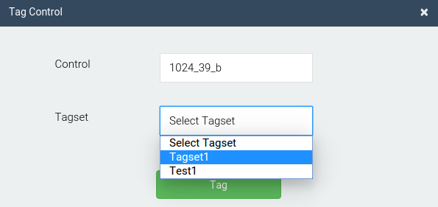

Figure 69: TCS Tag controls modal

* + - 1. Select the control name to be tagged from the drop down list.
      2. Select a tag set file from the second drop down list.
      3. Click on the **Tag** button to tag the control.

## Editing tags for controls

* + - 1. Click on the Edit tags button against the control whose tags have to be modified.

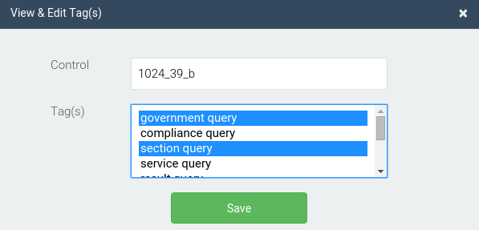

Figure 70: TCS Edit Tag modal

* + - 1. A modal window will open. Select the tags you wish to keep for the control using the multi select list.
      2. Click on the **Save** button to save the tags for the control.

## Tag policies

CMS allows the user to tag policy documents based upon a tag set file, similar to tagging regulations. Different section (paragraphs) of a policy can be tagged in this page automatically. The user can also modify generated tags for each section. The table lists the policy name, the policy version number, the tag set used to tag the policy, the corresponding tag set version number and options to delete the tagging.

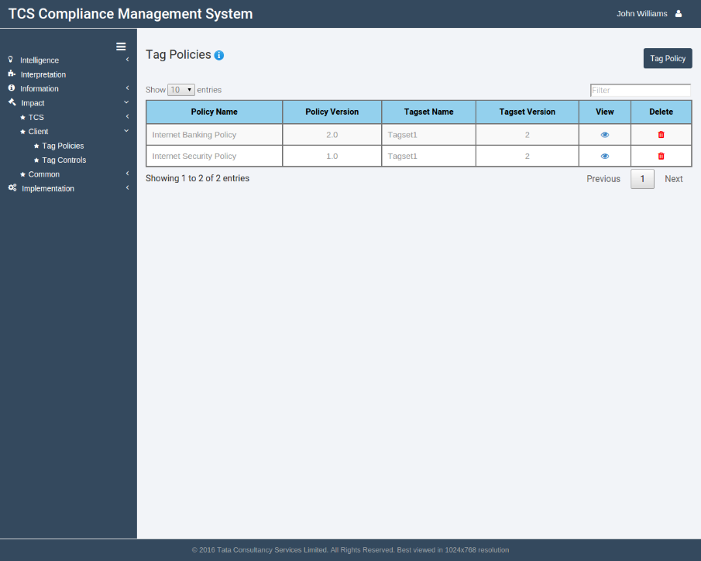

Figure 71: Tag Policies page

## Tagging a policy

* + - 1. Go to Impact>Client>Tag Policies by clicking corresponding icons in the sidebar.
      2. Click on the **Tag Policy** button at the top right, below the user account dropdown.

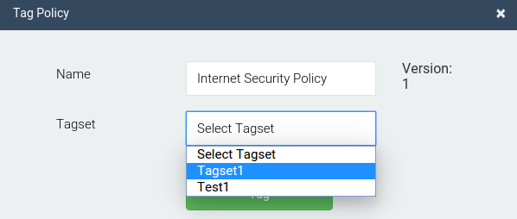

Figure 72: Tag Policies modal

* + - 1. Select the policy name to be tagged. The latest version number available for the policy will be displayed.
      2. Select a tag set file from the drop down list.
      3. Click on the **Tag** button to tag the policy document.

## Viewing a tagged policy

* + - 1. 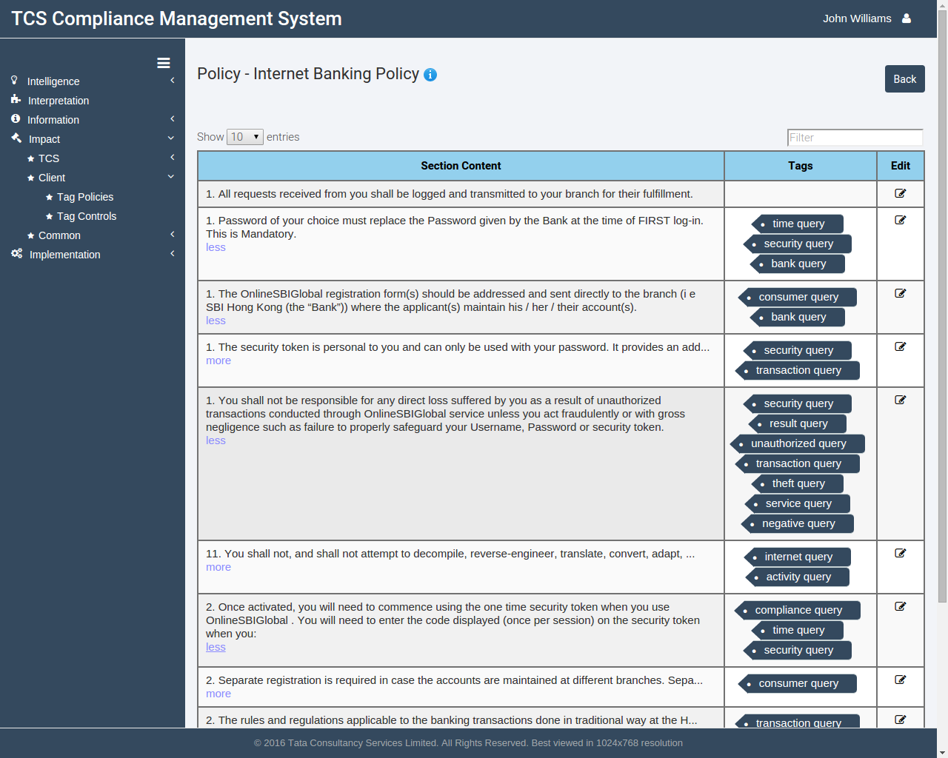Click on the View button against the policy you want to see the tags for.

Figure 73: Viewing tags of policies

* + - 1. The resultant page will list the policy in tabular format, with each row showing a section (paragraph) of the policy.
      2. Against each section, a list of tags auto-generated using CMS will be shown.

## Editing tags for sections

* + - 1. Click on the Edit button against the section whose tags have to be modified.

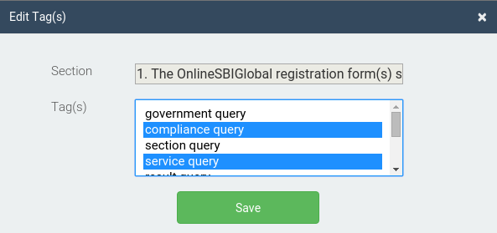

Figure 74: Edit tags for sections

* + - 1. A modal window will open. Select the tags you wish to keep for the section using the multi select list.
      2. Click on the **Save** button to save the tags for the section.

## Client tag controls

CMS allows the user to tag controls based upon a tag set file. All controls based upon a policy can be tagged in this page automatically. The user can also modify generated tags for each control. The table lists the control name, the tag set used to tag the control, the corresponding tag set version number, an option to edit the generated tags and an option to delete the tagging.

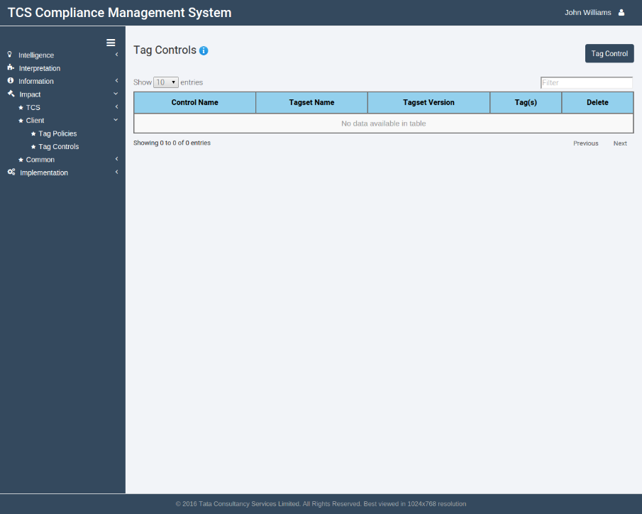

Figure 75: Client tag controls page

## Tagging a control

* + - 1. Go to Impact>Client>Tag Controls by clicking corresponding icons in the sidebar.
      2. Click on the **Tag Controls** button at the top right, below the user account dropdown.

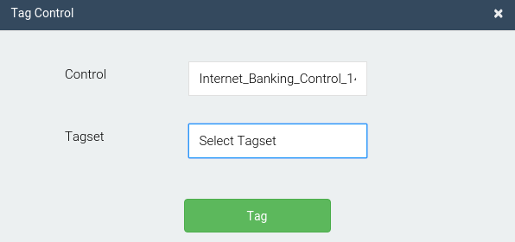

Figure 76: Client tag controls modal

* + - 1. Select the control name to be tagged from the drop down list.
      2. Select a tag set file from the second drop down list.
      3. Click on the **Tag** button to tag the control.

## Editing Tags for control

* + - 1. Click on the **Edit tags** button against the control whose tags have to be modified.

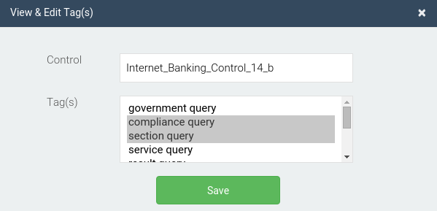

Figure 77: Editing tags for control modal

* + - 1. A modal window will open. Select the tags you wish to keep for the control using the multi select list.
      2. Click on the **Save** button to save the tags for the control.

## Tag sets

Tag set files are simple text based files (saved as *file_name.*ts.txt) that are used to generate tags for regulation and policy documents. This page allows a user to upload and modify tag sets so that they can then be used to tag documents and controls.

The table lists the name, the latest version of the tag set, and options to download, edit and delete the tag set file.

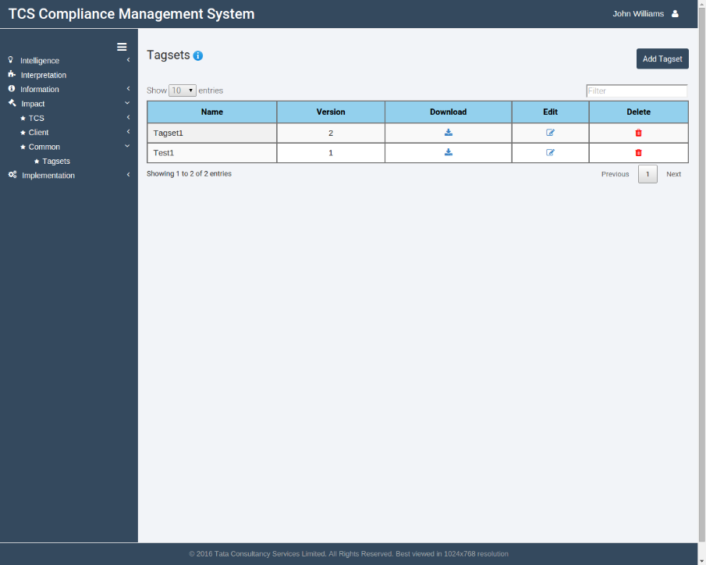

Figure 78: Tag-sets page

## Adding a new tag set

* + - 1. Go to Impact>Common>Tag sets by clicking corresponding icons in the sidebar.
      2. Click on the **Add Tag set** button at the top right, below the user account dropdown.

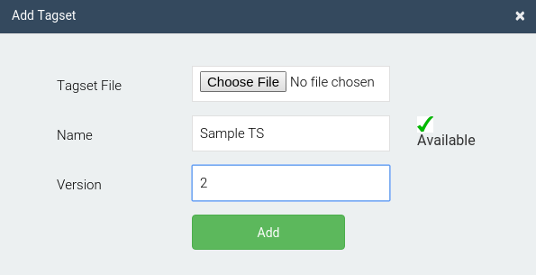

Figure 79: Add Tag-sets modal

* + - 1. A modal window will open. Select a tag set file from the file selector.
      2. Enter a unique name and enter the version number for the tag set file.
      3. Click on **Add** to process and save the tag set file.

## Downloading a tag set file

* + - 1. Click the **Download** button against the tag set file you wish to download.
      2. The file will start downloading in your browser in a short while.

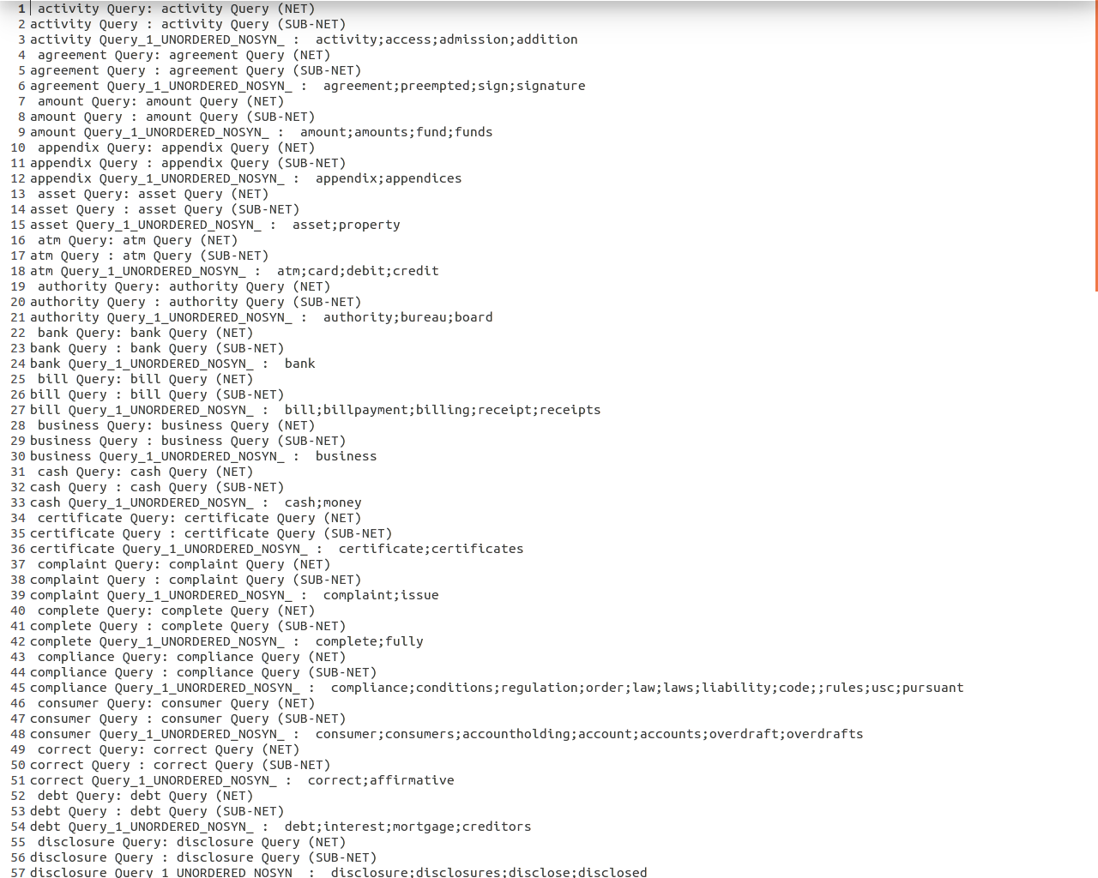

Figure 80: A sample tag set file

## Editing a tag set

* + - 1. Click the edit button against the tag set file to be edited.

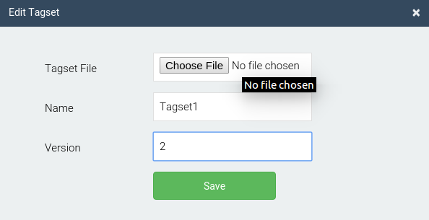

Figure 81: Editing tag set modal

* + - 1. A modal window will open. Select the new tag set file for the tag set.
      2. Enter a new version number. Note that the tag set name can't be edited.
      3. Click on the **Save** button to update the tag set with the new file.

# Implementation

This tab involves execution of controls and rules to ensure compliance of client data. Control execution results are stored here and the user can approve or reject the result of an execution. The user can also see a variety of reports in this section.



## TCS Control execution

Controls are basically a group of rules which can then be executed to check whether a key or a group of keys are compliant to that control or not. Thus, all keys compliant to a control are also compliant to the regulation to which the control belongs to.

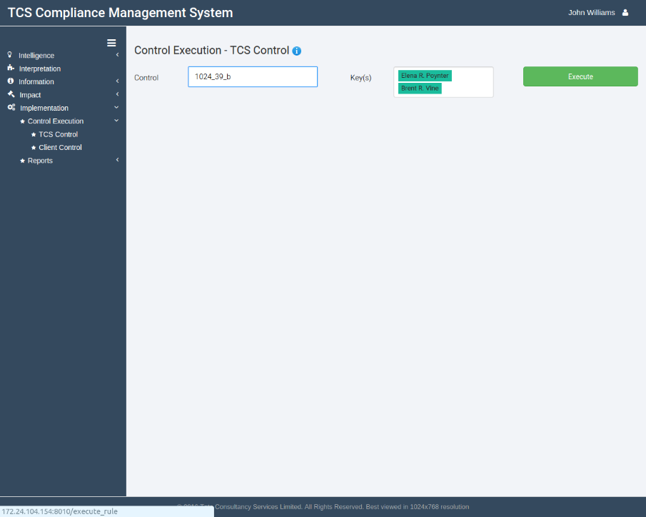

Figure 82: TCS Control execution page

## Using TCS Control execution

* + - 1. Go to Implementation>Control execution>TCS Control by clicking corresponding icons in the sidebar.
      2. Select the control which has to be executed using the drop down list.
      3. Select the key(s) for which compliance has to be checked using the multi select drop down list.
      4. Click on the **Execute** button to start the control execution.
      5. The following page will display the results of the control execution in a tabular format.

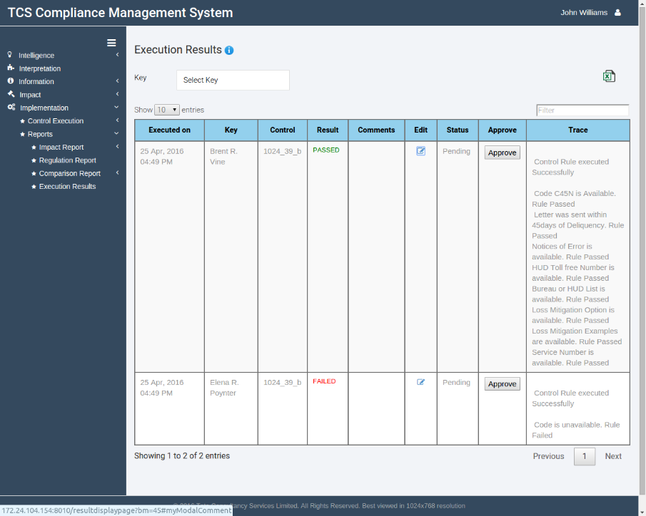

Figure 83: Execution results

* + - 1. The table lists the time stamp of control execution, the key name, the control name, the result, comments (initially blank) and an option to edit the comment.
      2. There is also a status field (initially pending), which can be approved by the user if he/she is satisfied with the control result.
      3. A stack trace displays the result of the control and a trace describing why the control passed/failed.
      4. You can export the result as an Excel sheet by clicking on the **Export as Excel** below the user account drop down at the top right.

## Client Control execution

Similar to executing controls based upon a regulation document, the user can also run controls created against a policy document. Thus, all keys compliant to that control are also compliant to the policy to which the control belongs to.

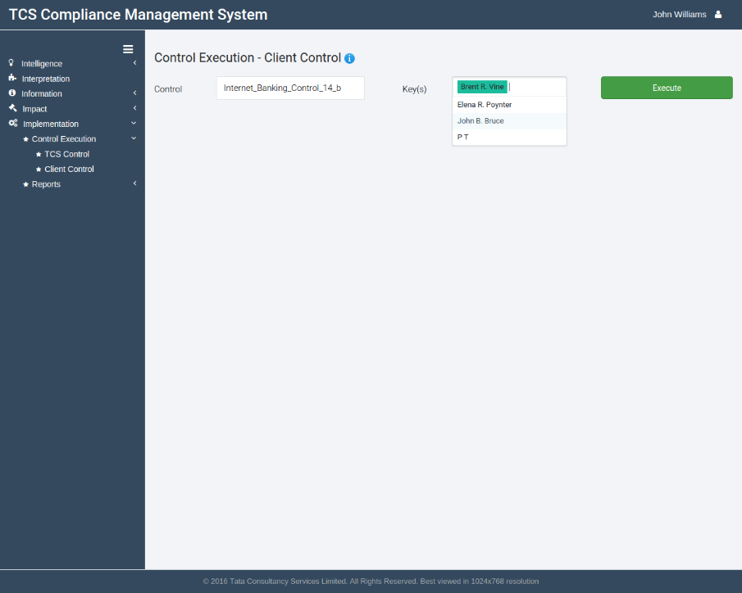

Figure 84 Client control execution page

## Using Client Control execution

* + - 1. Go to Implementation>Control execution>Client Control by clicking corresponding icons in the sidebar.
      2. Select the control which has to be executed using the drop down list.
      3. Select the key(s) for which compliance has to be checked using the multi select drop down list.
      4. Click on the **Execute** button to start the control execution.
      5. You'll soon get a confirmation flash telling that the control has been successfully executed.

## Reports

CMS provides a number of different reports for the users to keep track of document versions, control executions, document impact etc. The different report types are:

1. Impact Report
   * Regulation
   * Policy
   * Control
     + TCS Control
     + Client Control
2. Regulation Report
3. Comparison Report
   * Regulation
   * Policy
4. Execution Results

## Impact Reports- Regulation

Regulation impact reports help the user to check the impact of a regulation section on different policies and TCS controls, i.e., the user can check which regulation sections have a different impact on which policies and controls.

Please note that it is necessary that the regulation has been tagged before the impact report can be run on a regulation section.

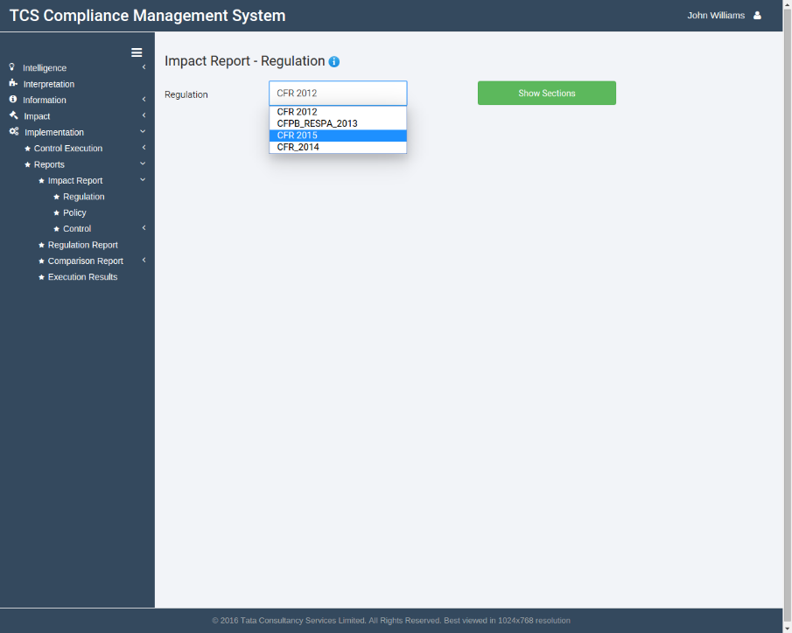

Figure 85 Impact report-regulation page

## Generating impact report-regulation

* + - * 1. Go to Implementation>Reports>Impact Report>Regulation by clicking corresponding icons in the sidebar.
        2. Select the regulation for which you want to generate the impact report using the drop down list.
        3. Click on the **Show Sections** button.
        4. You will be shown the list of sections of the regulation document. Click on the check box against the section for which the report has to be generated.
        5. Click on the **Show** **Impact** button at the bottom and wait for the report to be generated.

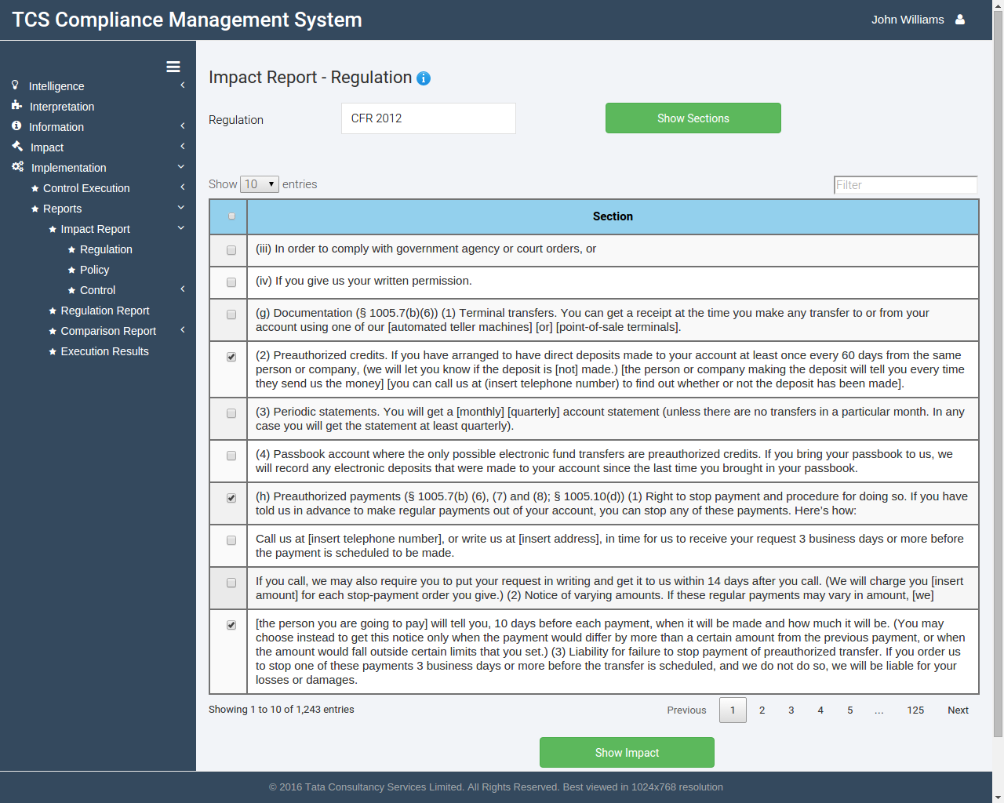

Figure 86 Impact report-regulation generation

* + - * 1. The resultant page will show a table which will list all regulation sections selected by you and the policies with the corresponding policy sections they'll impact. The common tags between the two will also be listed.

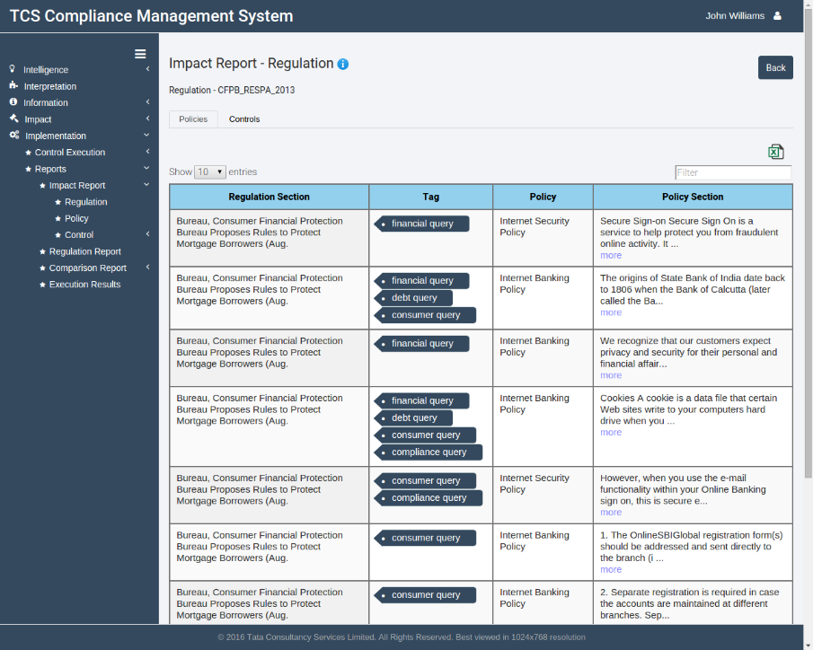

Figure 87 Impact report-regulation (policies)

* + - * 1. To list the controls that will be impacted by the regulation, click on the **Controls** tab below the regulation name.

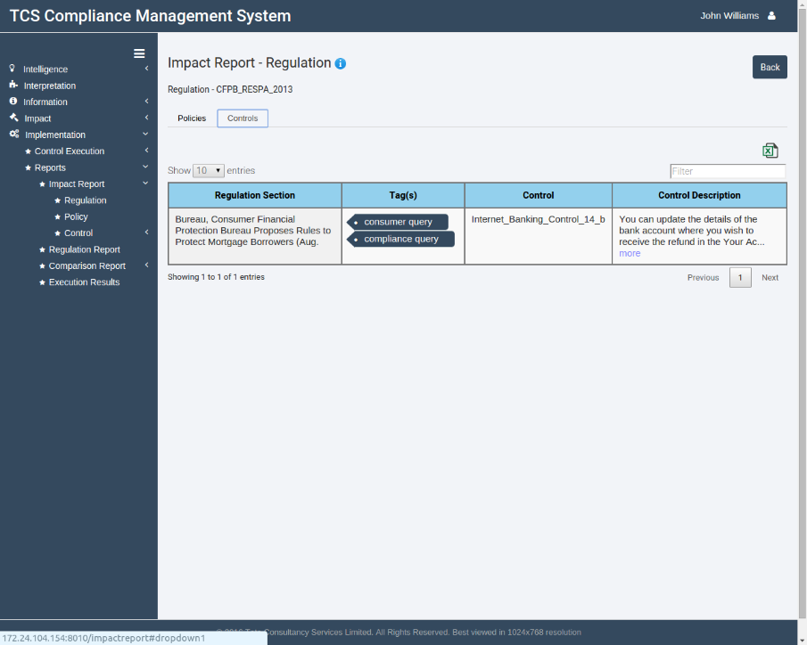

Figure 88 Impact report-regulation (controls)

* + - * 1. To export the impact results to an excel sheet, click on the **Export** **to** **Excel** button at the top right below the Back button.

## Impact Reports- Policy

Policy impact reports help the user to check the impact of a policy section on different regulations and client controls, i.e., the user can check which policy sections have a different impact on which regulations and controls.

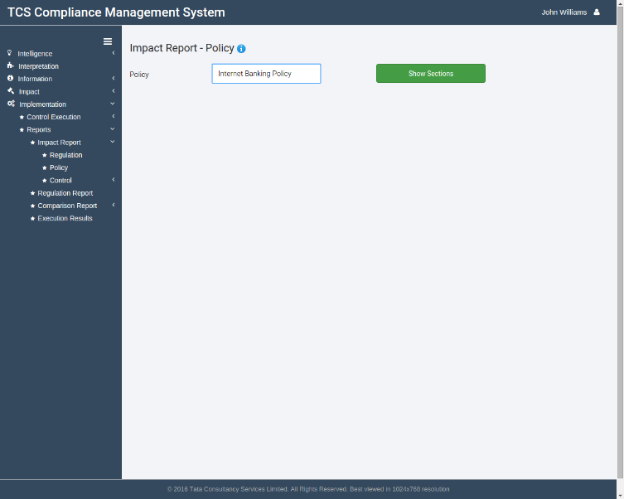Please note that it is necessary that the policy has been tagged before the impact report can be run on a policy section.

Figure 89 Impact report-Policy page

## Generating impact report-policy

* + - * 1. Go to Implementation>Reports>Impact Report>Policy by clicking corresponding icons in the sidebar.
        2. Select the policy for which you want to generate the impact report using the drop down list.
        3. 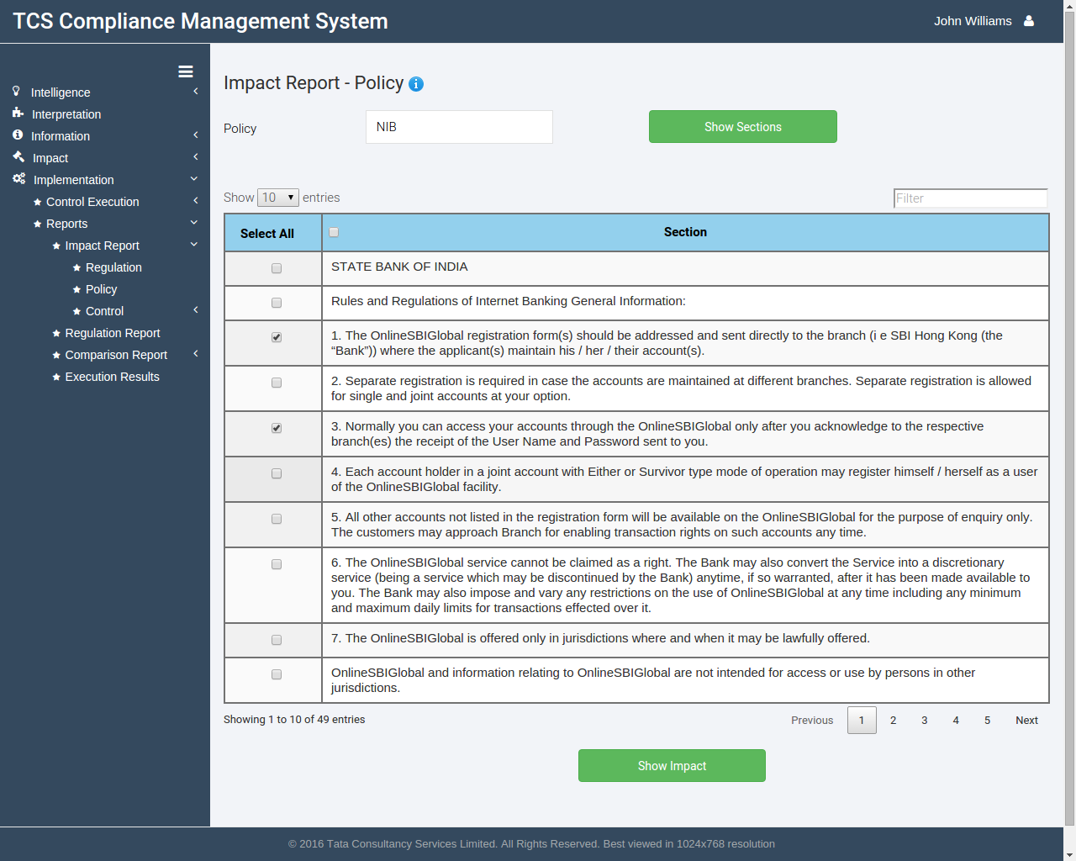Click on the **Show Sections** button.

Figure 90 Impact report-Policy generation

* + - * 1. You will be shown the list of sections of the policy document. Click on the check box against the section for which the report has to be generated.
        2. 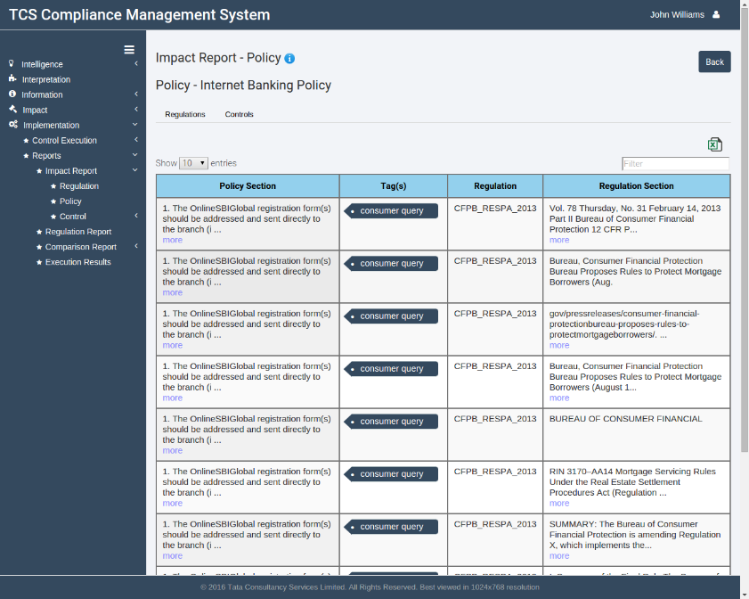Click on the **Show** **Impact** button at the bottom and wait for the report to be generated.

Figure 91 Impact report-policy (regulations)

* + - * 1. The resultant page will show a table which will list all policy sections selected by you and the regulations with the corresponding regulation sections they'll impact. The common tags between the two will also be listed.
        2. 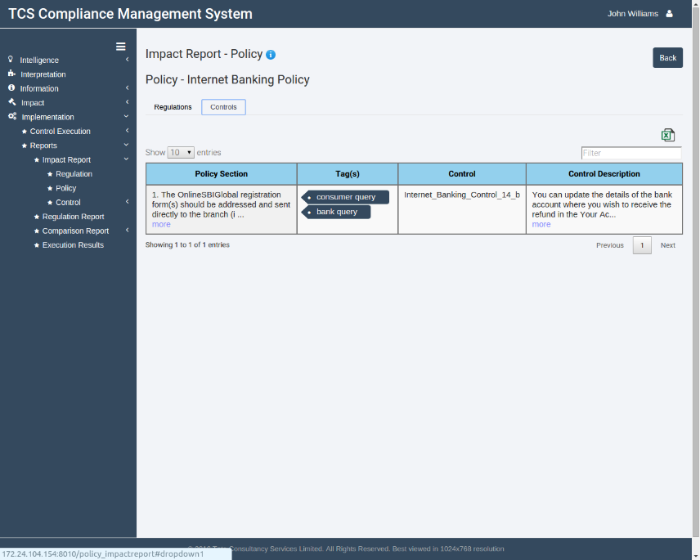To list the controls that will be impacted by the policy, click on the **Controls** tab below the policy name.

Figure 92 Impact report-policy (controls)

* + - * 1. To export the impact results to an excel sheet, click on the **Export to Excel** button at the top right below the Back button.

## Impact reports-TCS control

TCS Control reports help the user to check the impact of a control on different sections of regulation documents, i.e., the user can check which controls have a different impact on which regulations.

Please note that it is necessary that the control has been tagged before the impact report can be run on a control.

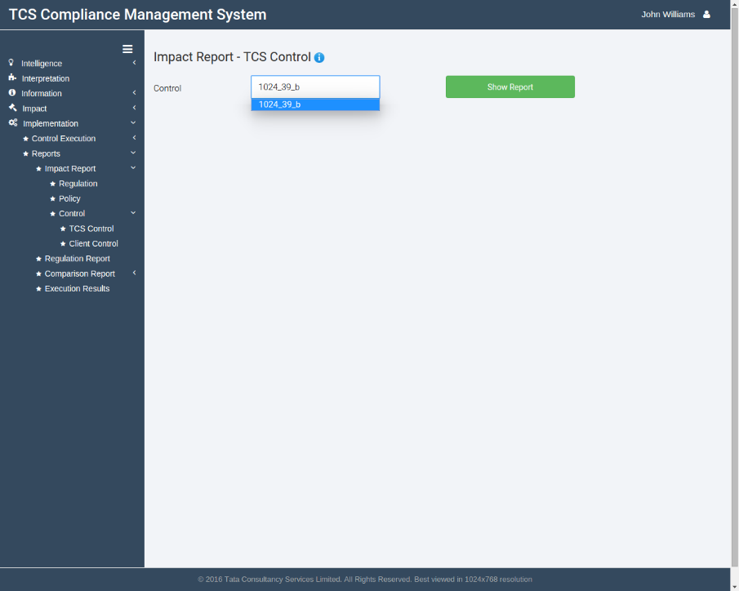

Figure 93 Impact report TCS control page

## Generating impact report-TCS control

* + - * 1. Go to Implementation>Reports>Impact Report>Control>TCS Control by clicking corresponding icons in the sidebar.
        2. Select the control for which you want to generate the impact report using the drop down list.
        3. Click on the **Show** **Report** button and wait for the report to be generated.

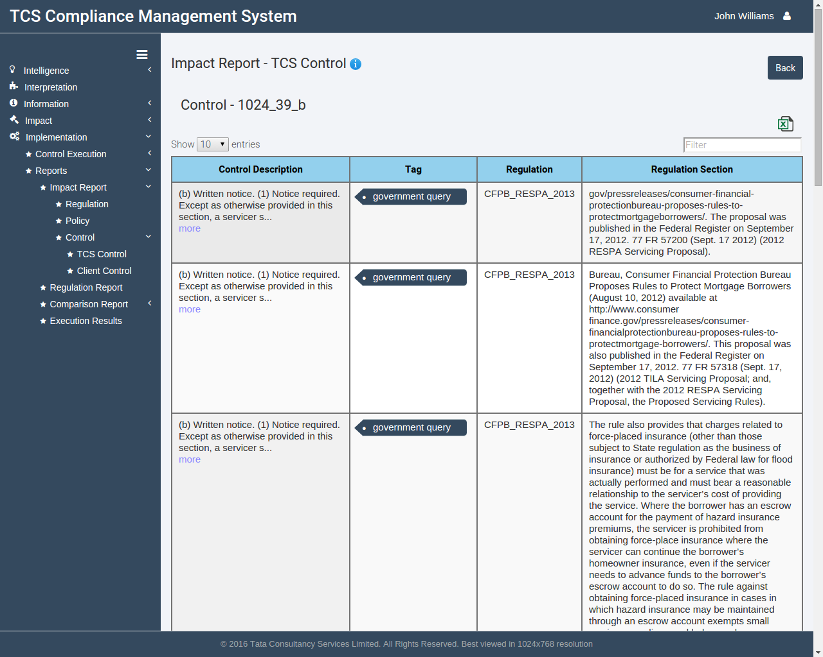

Figure 94 Impact report TCS control

* + - * 1. The resultant page will show a table which will list the description of control selected by you and the regulations with the corresponding regulation sections they'll impact. The common tags between the two will also be listed.
        2. To export the impact results to an excel sheet, click on the **Export** **to** **Excel** button at the top right below the Back button.

## Impact reports-Client control

Client Control reports help the user to check the impact of a control on different sections of policy documents, i.e., the user can check which controls have a different impact on which policies.

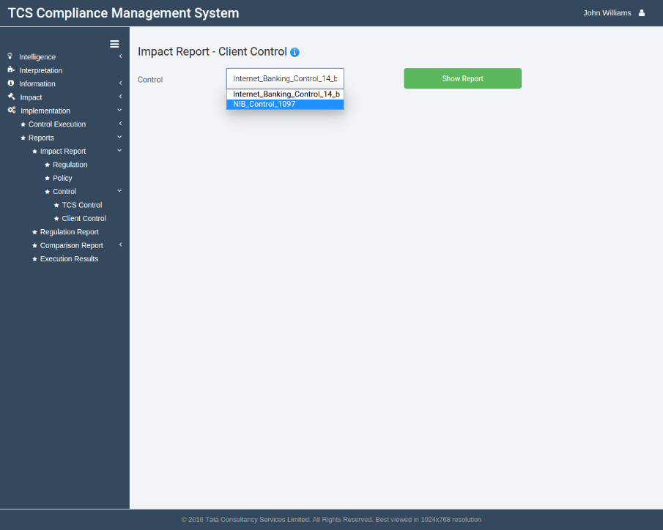Please note that it is necessary that the control has been tagged before the impact report can be run on a control.

Figure 95 Impact report Client control page

## Generating Impact reports-Client control

* + - * 1. Go to Implementation>Reports>Impact Report>Control>Client Control by clicking corresponding icons in the sidebar.
        2. Select the control for which you want to generate the impact report using the drop down list.
        3. Click on the **Show Report** button and wait for the report to be generated.

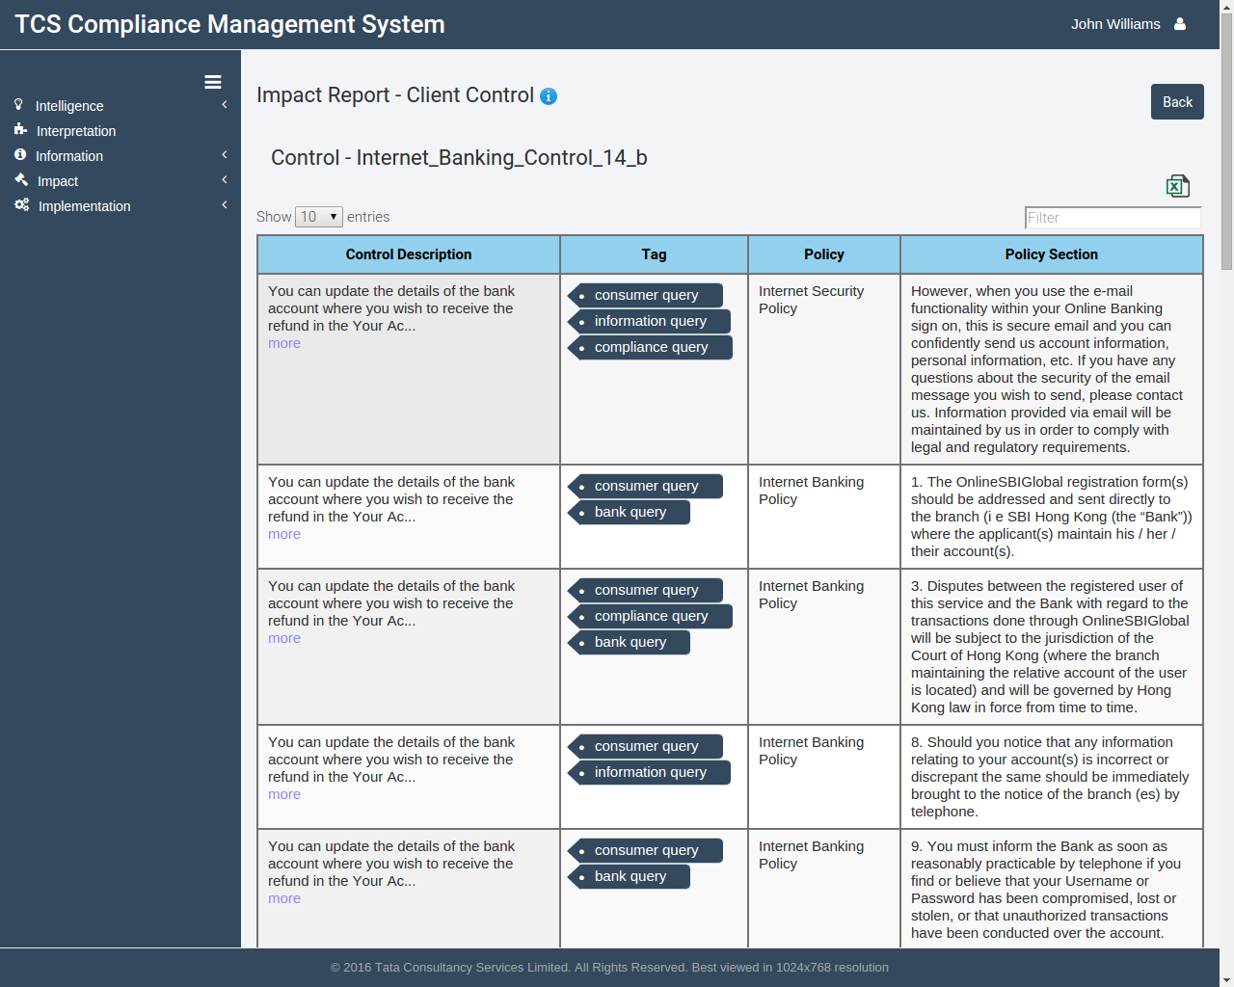

Figure 96 Impact report Client control generation

* + - * 1. The resultant page will show a table which will list the description of control selected by you and the policies with the corresponding policy sections they'll impact. The common tags between the two will also be listed.
        2. To export the impact results to an excel sheet, click on the **Export** **to** **Excel** button at the top right below the Back button.

## Regulation Reports

Regulation reports allow the user to track compliance of customers with a particular regulation. The user can check whether a particular key is compliant to a control or not.

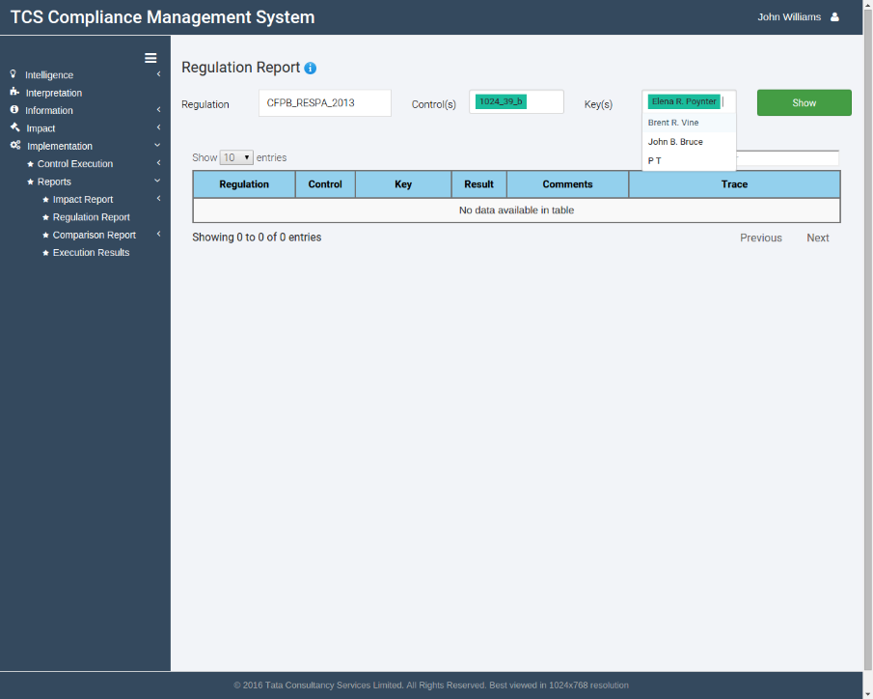

Figure 97 Regulation reports page

## Generating Regulation Reports

* + - * 1. Go to Implementation>Reports>Regulation Report by clicking corresponding icons in the sidebar.
        2. Select the regulation for which you want to generate the regulation report using the drop down list. The system will fetch all controls linked to that regulation and populate the control(s) drop-down list.
        3. Select the control(s) against which compliance has to be checked.
        4. Select the key(s) for which the compliance has to be checked.
        5. Click on the **Show** button and wait for the report to be generated.
        6. The following page will show the execution history of the control for that key, along with the results, comments and the corresponding stack trace for each execution run.

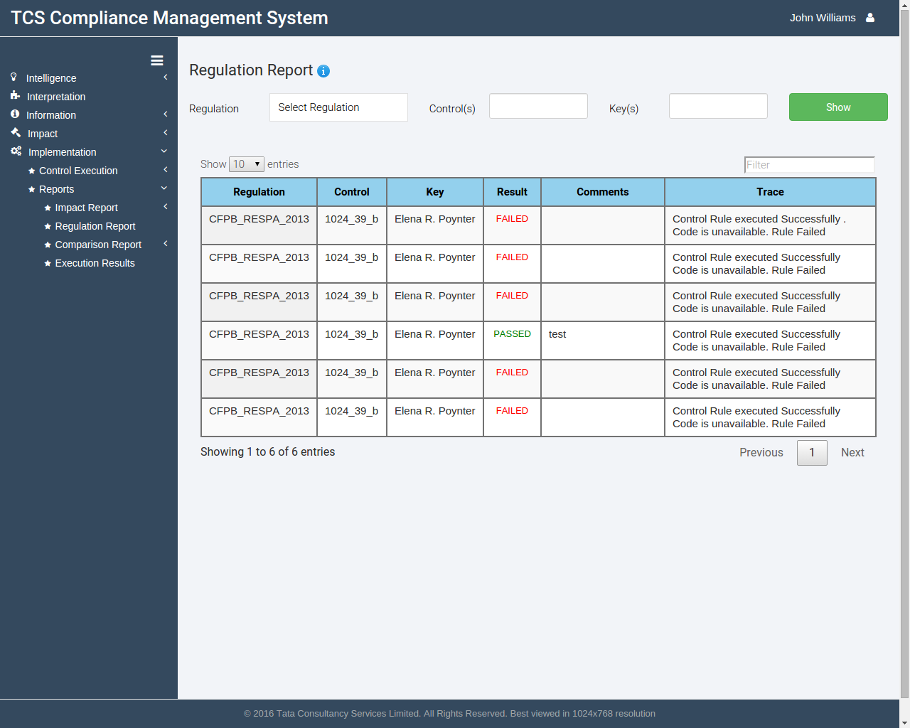

Figure 98 Regulation reports generation

## Comparison reports-regulation

Regulation comparison reports allow user to keep track of changes between different versions of the same regulation document. CMS maintains a version history of all documents saved into the application. You can then compare different versions, see changes across the documents or just see sections having variations.

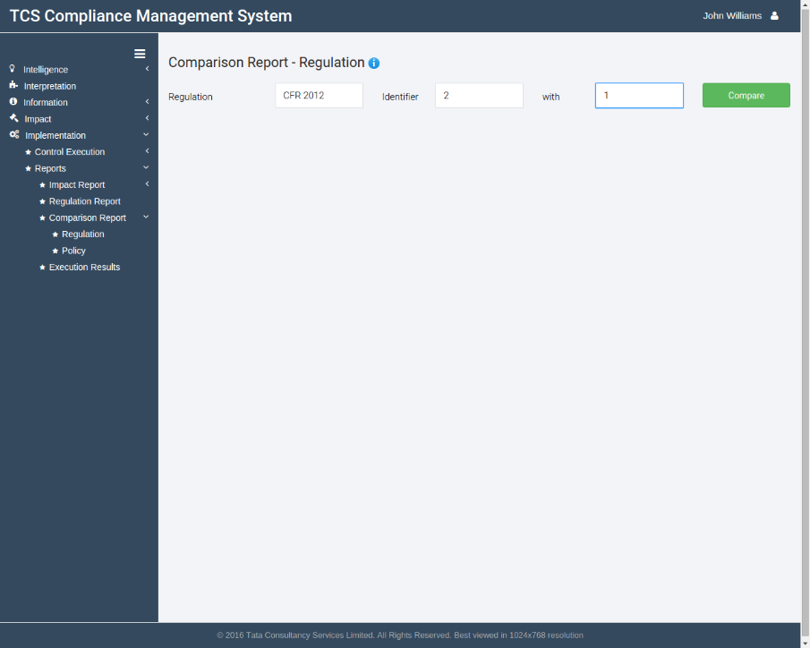

Figure 99 Comparison report-regulation page

## Generating Comparison reports-regulation

* + - * 1. Go to Implementation>Reports>Comparison Report>Regulation by clicking corresponding icons in the sidebar.
        2. Select the regulation for which you want to generate the comparison report using the drop down list. The system will fetch all versions of that regulation and populate the following two drop-down lists.
        3. Select the first version identifier (source) and the second version identifier (target).
        4. 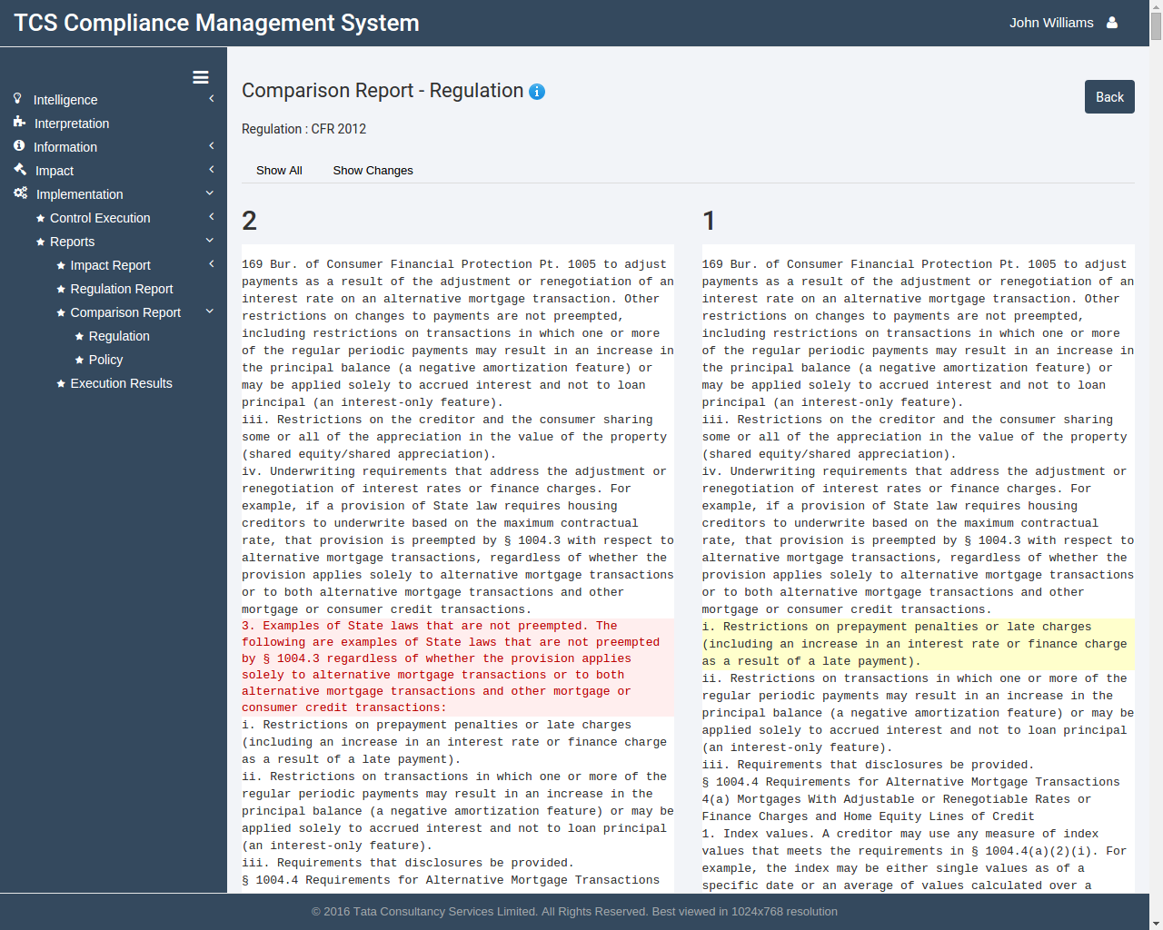Click on the **Compare** button and wait for the report to be generated.

Figure 100 Comparison report-regulation- all

* + - * 1. The following page will provide a complete comparison between the two identifiers selected. A section in red signifies that it is not present the second version. A section in green signifies it has been added in the second version only. Hovering over a section will highlight it yellow.
        2. To see just the changes between the documents rather than comparing the entire documents, click on the **Show** **Changes** tab below the regulation name at the top of the page.

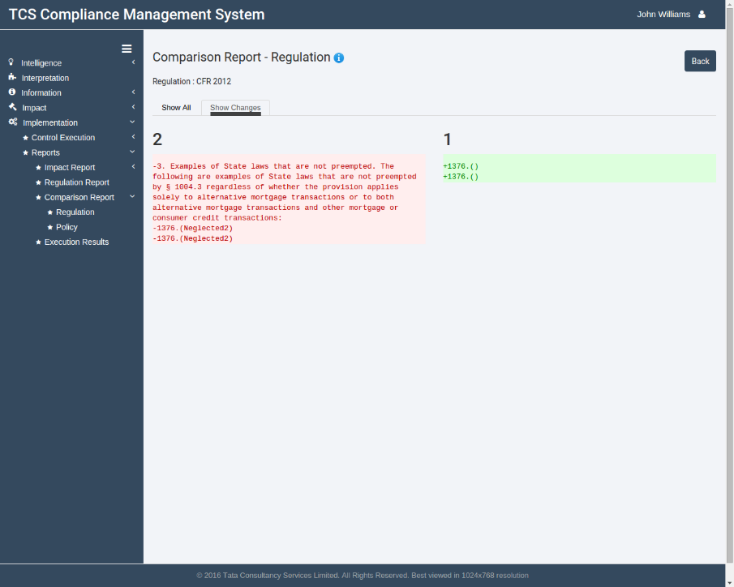

Figure 101 Comparison report-regulation- changes

## Comparison reports-policy

Policy comparison reports allow user to keep track of changes between different versions of the same policy document. CMS maintains a version history of all documents saved into the application. You can then compare different versions, see changes across the documents or just see sections having variations.

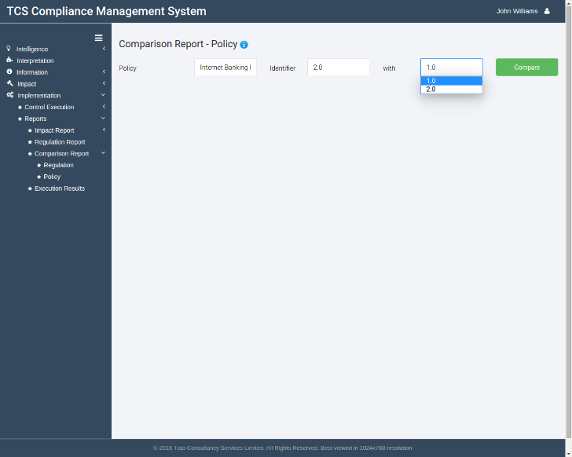

Figure 102 Comparison report- policy page

## Generating Comparison reports-policy

* + - * 1. Go to Implementation>Reports>Comparison Report>Policy by clicking corresponding icons in the sidebar.
        2. Select the policy for which you want to generate the comparison report using the drop down list. The system will fetch all versions of that policy and populate the following two drop-down lists.
        3. Select the first version identifier (source) and the second version identifier (target).
        4. 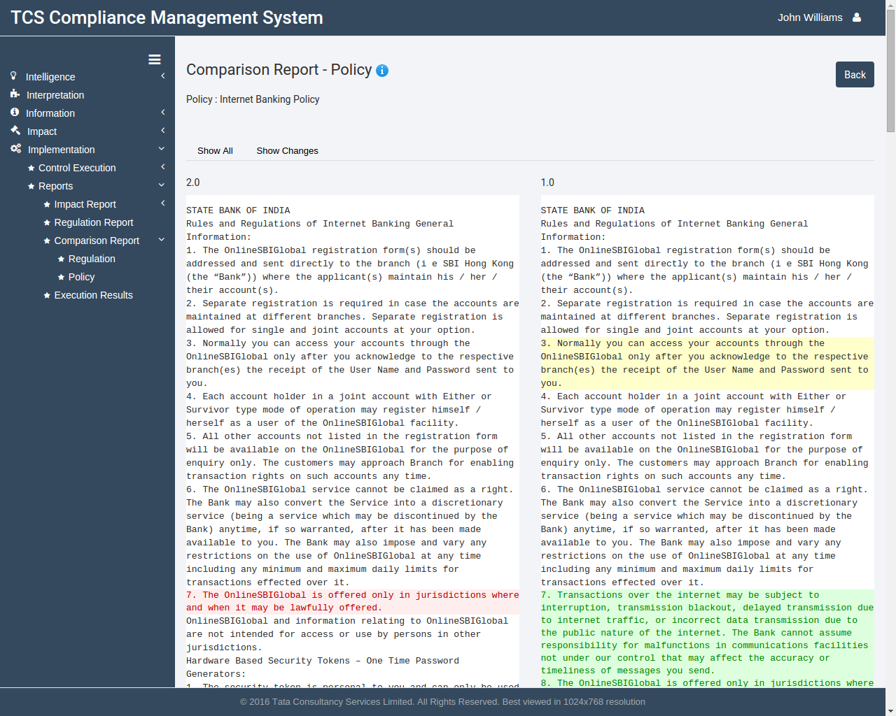Click on the **Compare** button and wait for the report to be generated.

Figure 103 Comparison report-policy- all

* + - * 1. The following page will provide a complete comparison between the two identifiers selected. A section in red signifies that it is not present the second version. A section in green signifies it has been added in the second version only. Hovering over a section will highlight it yellow.
        2. To see just the changes between the documents rather than comparing the entire documents, click on the **Show** **Changes** tab below the regulation name at the top of the page.

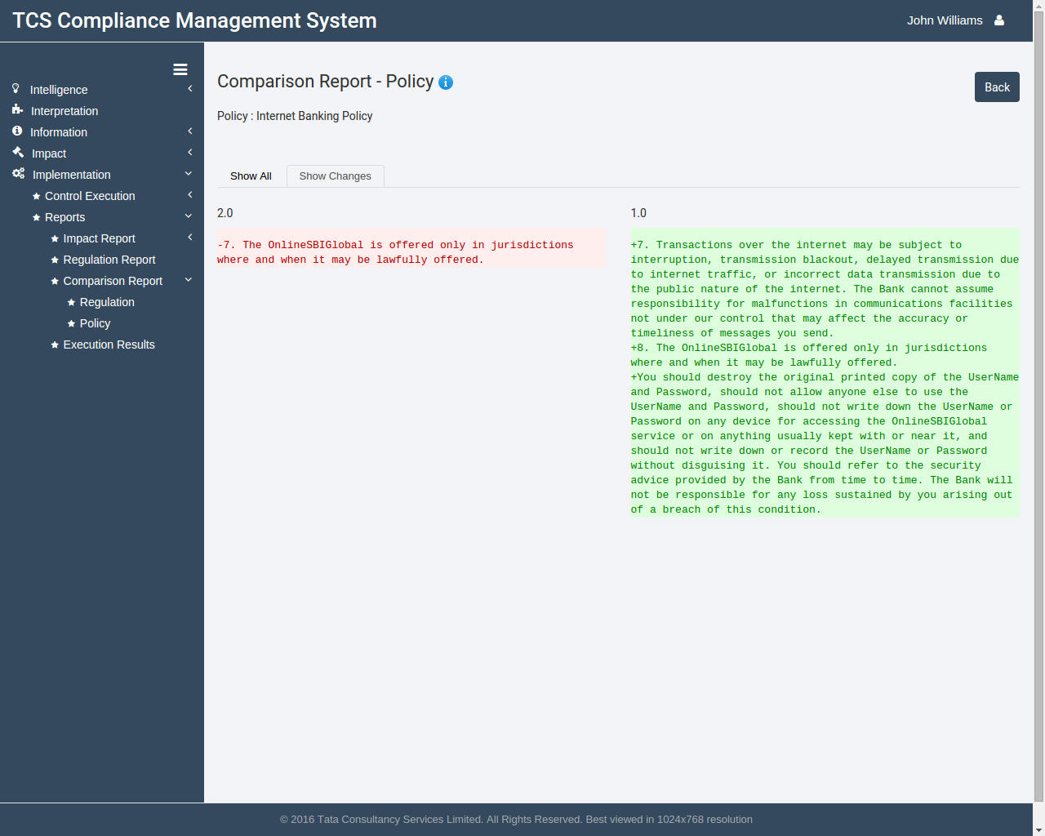

Figure 104 Comparison report-policy- changes

## Execution results

Execution results page allows the user to track all control executions that have happened on different keys. The table lists the timestamp of control execution, the key name, the control name, the actual result of the control in a particular run and comments added by the user. There is also an option to modify the details and to approve the execution result. The original stack trace of the execution run is also shown in the report.

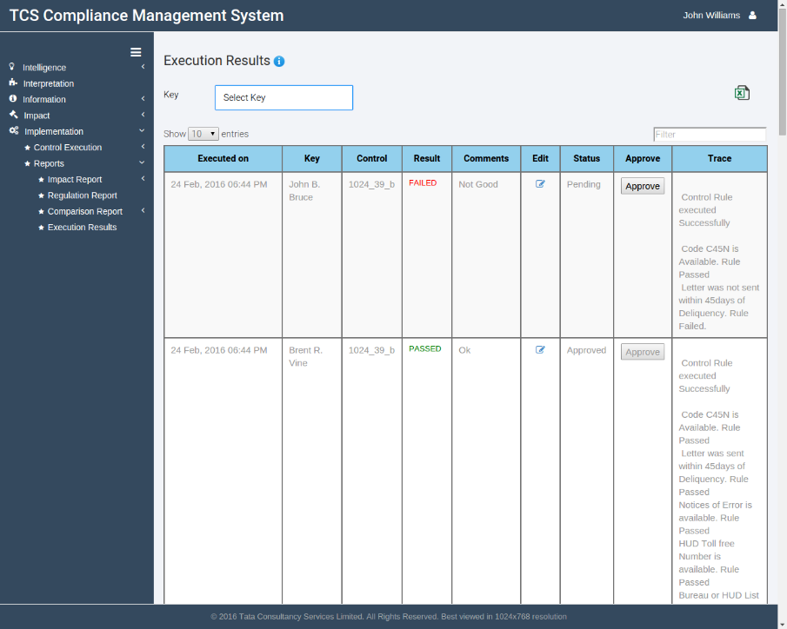

Figure 105 Execution results page

## Generating execution results reports

* + - * 1. Go to Implementation>Reports>Execution results by clicking corresponding icons in the sidebar.
        2. To filter results for a particular key, select the key from the drop down at the top of the page.
        3. You can also export the results to an Excel sheet by clicking on the **Export** **to** **Excel** button at the top right below the user account dropdown.

## Editing execution results reports

* + - * 1. Click on the Edit button against the entry you wish to modify.

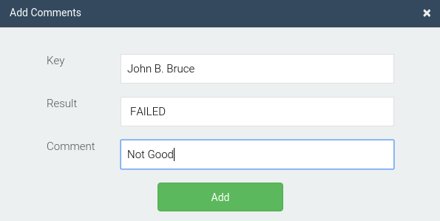

Figure 106 Editing execution results reports

* + - * 1. A modal window will open. You can update the result by selecting Passed/Failed from the drop down list and editing the comments added.
        2. Click on the **Add** button to save the entry.
        3. To approve a particular run of execution, simply press the **Approve** button against that particular entry.